**DATA SPARK-ILLUMINATING INSIGHTS FOR GLOBAL ELECTRONICS**

**1.Objective:**

The objective of Data Spark is to analyse data from the global electronics retail industry to extract actionable insights. The project aims to improve decision-making in areas like sales trends, customer behaviour, and inventory management by using data-driven methodologies. The project will cover data cleaning, exploratory data analysis (EDA), data management using SQL, and data visualization using Power BI/Tableau.

**2. Tools and Technologies Used3**

* **Programming Language:** Python
* **Data Processing and Analysis:** Pandas, NumPy
* **Data Visualization:** Matplotlib, Seaborn, Power BI, or Tableau
* **IDE:** Jupyter Notebook
* **Database Management System:** MySQL
* **Dashboarding:** Power BI/Tableau

**3. Skills Acquired**

* **Data Cleaning and Preprocessing:** Techniques for handling missing data, removing duplicates, and preparing the data for analysis.
* **Exploratory Data Analysis (EDA):** Gaining insights through statistical analysis, data visualization, and identifying trends or anomalies.
* **Python Programming:** Data analysis and visualization using Python libraries such as Pandas, NumPy, Matplotlib, and Seaborn.
* **SQL for Data Management:** SQL queries for extracting, filtering, and analyzing large datasets from databases.
* **Dashboard Creation with Power BI/Tableau:** Building dynamic and interactive dashboards to present the analytical results.

**4. Dataset Description**

The dataset used in this project represents retail data from the electronics industry. It contains various key metrics including:

* **Sales Data:** Information on products sold, their quantities, and revenue.
* **Product Information:** Product names, categories, and pricing details.
* **Customer Data:** Demographic information such as age, gender, and location.
* **Transaction Data:** Purchase timestamps, transaction IDs, and payment methods.
* **Inventory Data:** Stock levels, product availability, and restocking information.

**Sample Fields:**

* Product_ID
* Product_Name
* Category
* Price
* Quantity_Sold
* Revenue
* Transaction_Date
* Customer_ID
* Location

**5. Project Phases**

**Phase 1: Data Collection and Understanding**

* **Objective:** Understand the structure and contents of the dataset.
* **Steps:**
  1. Load the dataset into Python for initial examination.
  2. Check for missing values, duplicates, and irrelevant data.

3. Understand the relationship between different columns.

**Phase 2: Data Cleaning and Preprocessing**

* **Objective:** Prepare the dataset for analysis.
* **Steps:**
  1. Handle missing or null values using methods like imputation or removal.
  2. Remove duplicates to ensure data accuracy.
  3. Convert data types and formats as necessary (e.g., converting date columns to a datetime format).
  4. Normalize/standardize numerical features if necessary (e.g., scaling prices).
  5. Identify and address outliers using visualization techniques like boxplots.

**Phase 3: Exploratory Data Analysis (EDA)**

* **Objective:** Gain initial insights and understand key trends in the data.
* **Steps:**
  1. **Univariate Analysis:** Analyze each feature independently (e.g., sales distribution, price range of products).
  2. **Bivariate Analysis:** Analyze relationships between two variables (e.g., product price vs. quantity sold).
  3. **Multivariate Analysis:** Use correlation analysis to identify relationships between multiple variables (e.g., how product categories, pricing, and location impact sales).
  4. **Visualization:** Use bar charts, histograms, heatmaps, and scatter plots to visualize sales trends, customer demographics, and inventory levels.

**Phase 4: SQL Integration for Data Management**

* **Objective:** Use SQL to manage and query large datasets for more efficient analysis.
* **Steps:**
  1. Import the dataset into an SQL database.
  2. Write SQL queries to extract relevant data (e.g., product sales by region, top-selling products).
  3. Perform data aggregation, filtering, and sorting using SQL commands.
  4. Combine SQL with Python to conduct advanced analysis.

**Phase 5: Data Analysis and Insights**

* **Objective:** Generate actionable insights to improve business operations.
* **Key Areas to Analyze:**
  1. **Sales Trends:** Identify peak sales periods, top-selling products, and high-performing regions.
  2. **Customer Insights:** Analyze customer demographics to understand purchasing patterns.
  3. **Inventory Analysis:** Evaluate stock levels, optimize inventory management, and forecast demand using historical data.
  4. **Product Performance:** Assess how different products perform in various markets.

**Phase 6: Data Visualization and Reporting**

* **Objective:** Create interactive dashboards and reports to visualize findings.
* **Tools:** Power BI
* **Steps:**
  1. **Create Dashboards:** Build real-time dashboards to display KPIs (Key Performance Indicators), including:
     + Total sales over time
     + Region-wise sales performance
     + Product-wise sales performance
     + Customer segmentation
  2. **Reports:** Generate detailed reports for stakeholders, summarizing key findings and recommendations.
  3. **Interactivity:** Implement filters (e.g., by region, product category, or time period) to allow for dynamic analysis.

**6. Results and Insights**

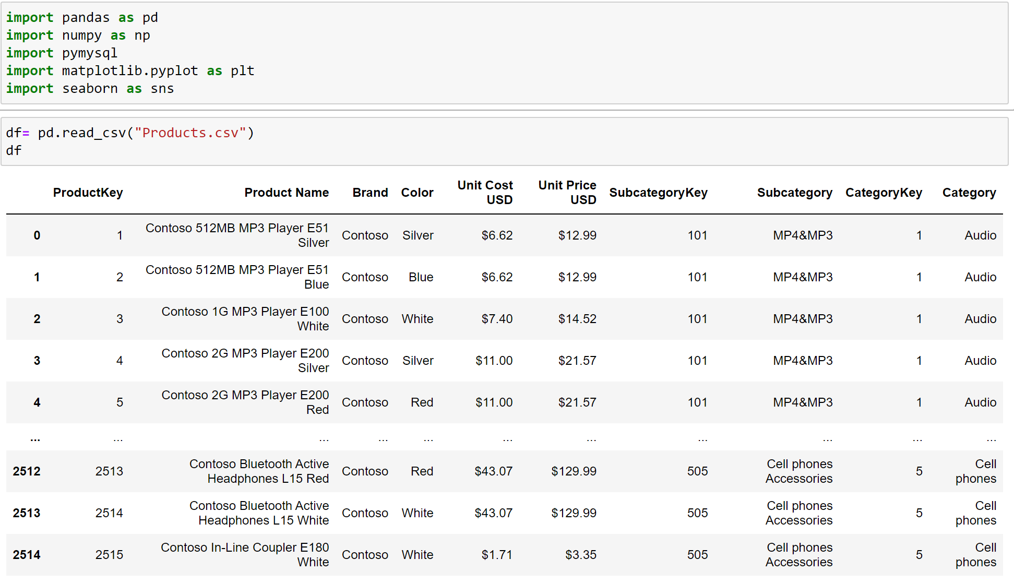

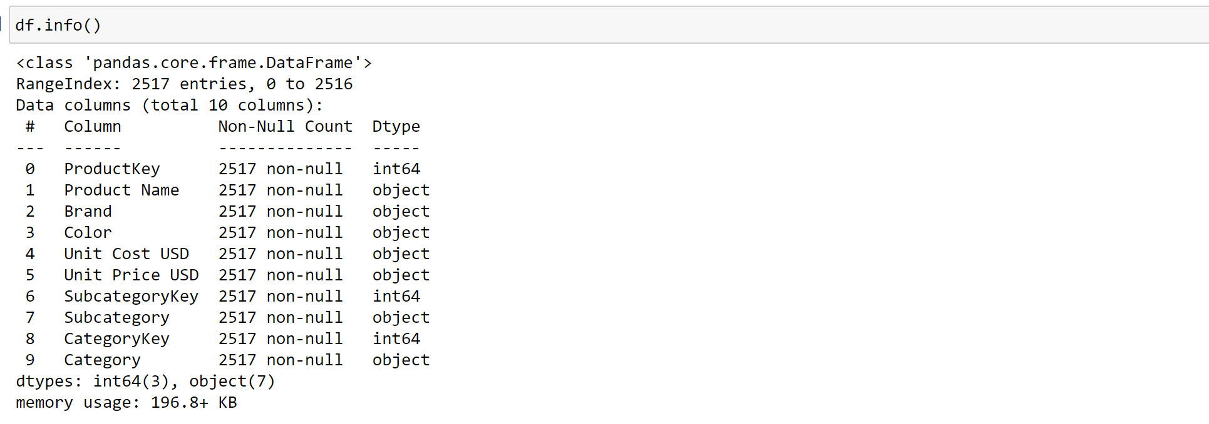

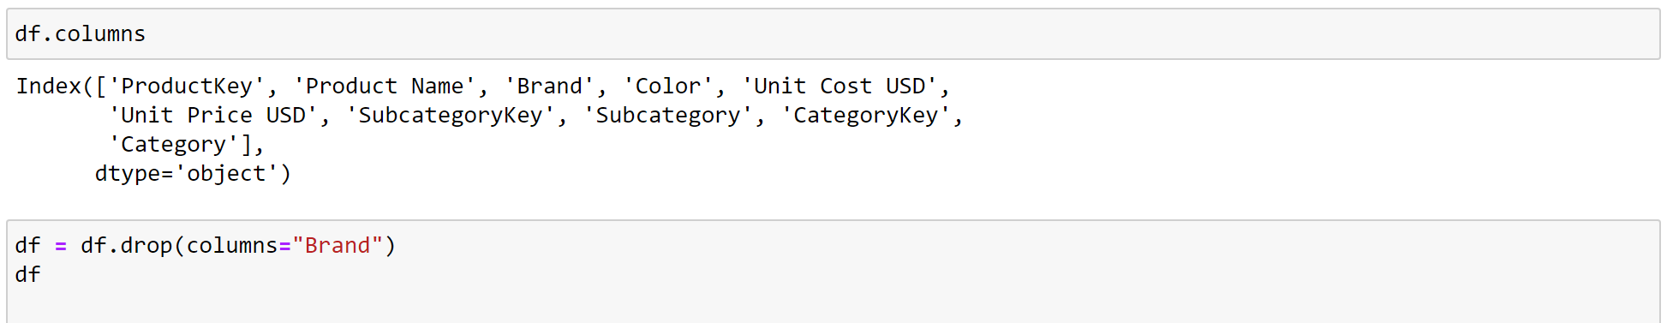

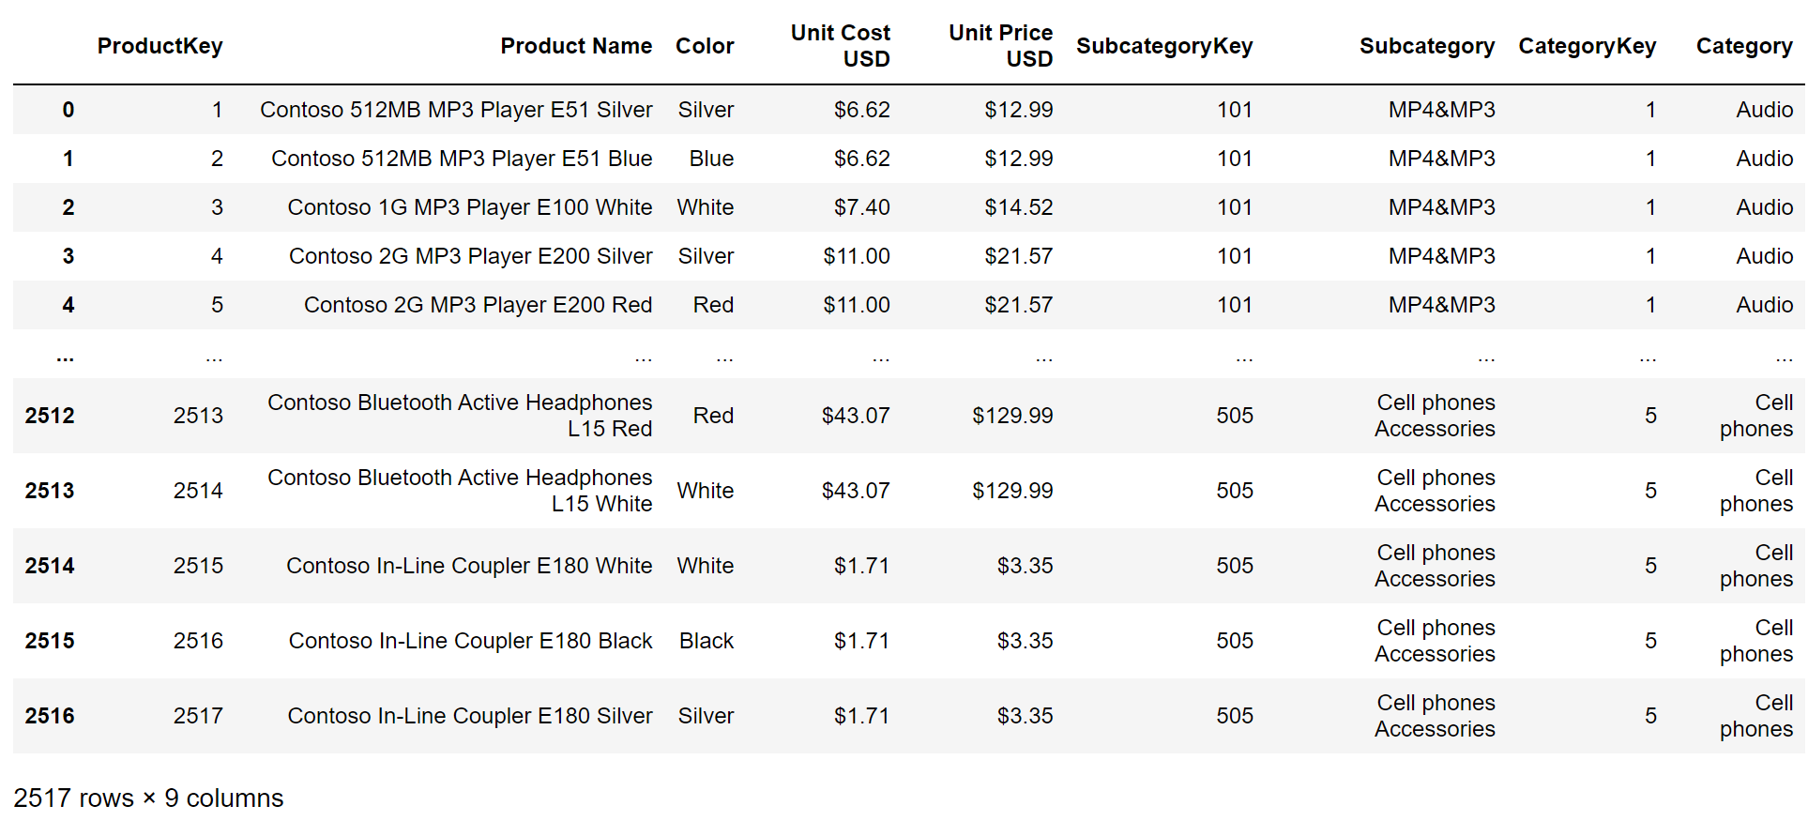

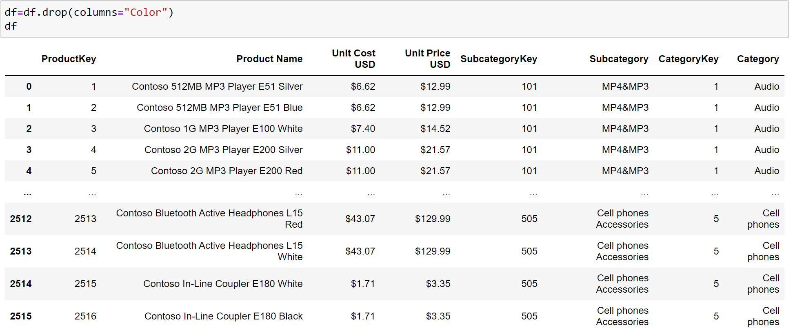

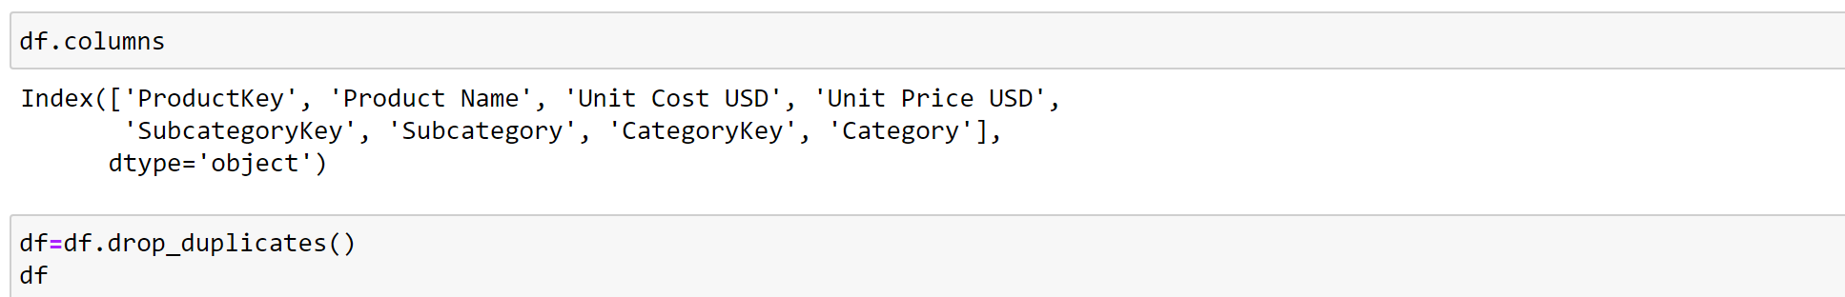

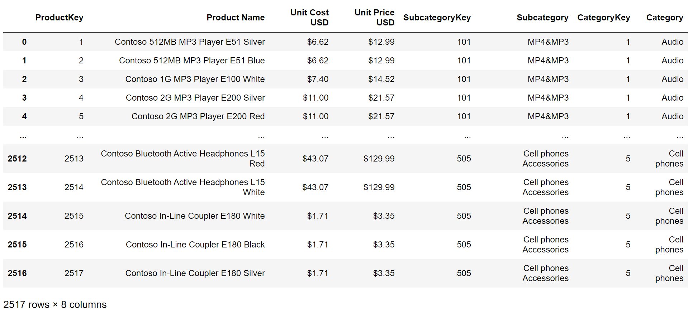

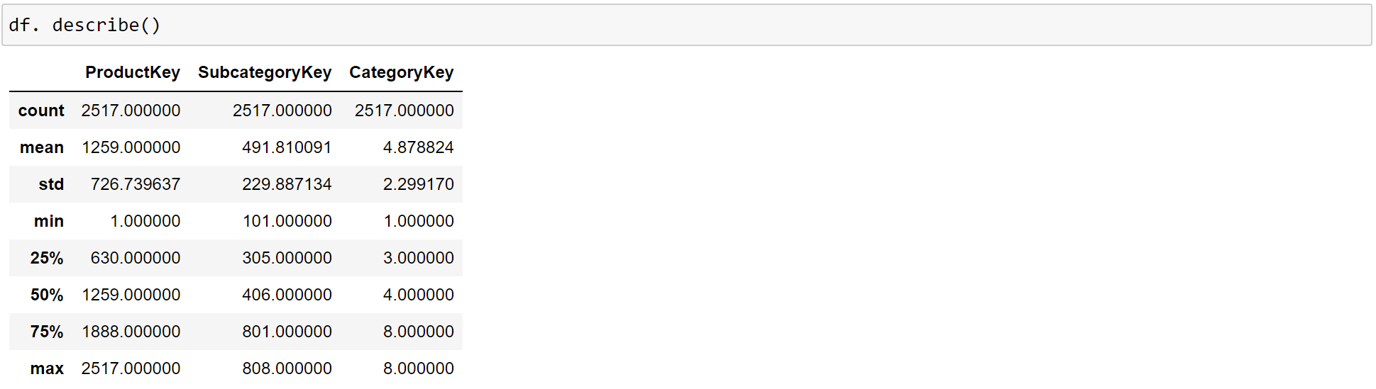

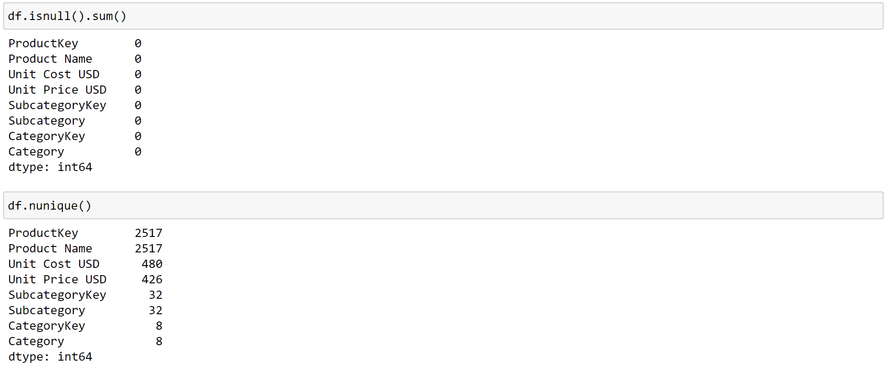

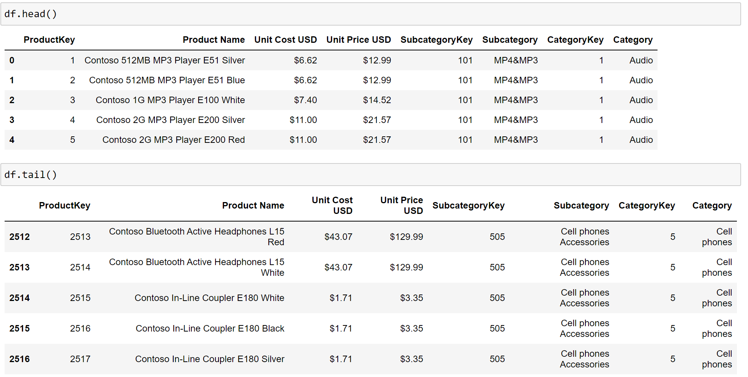

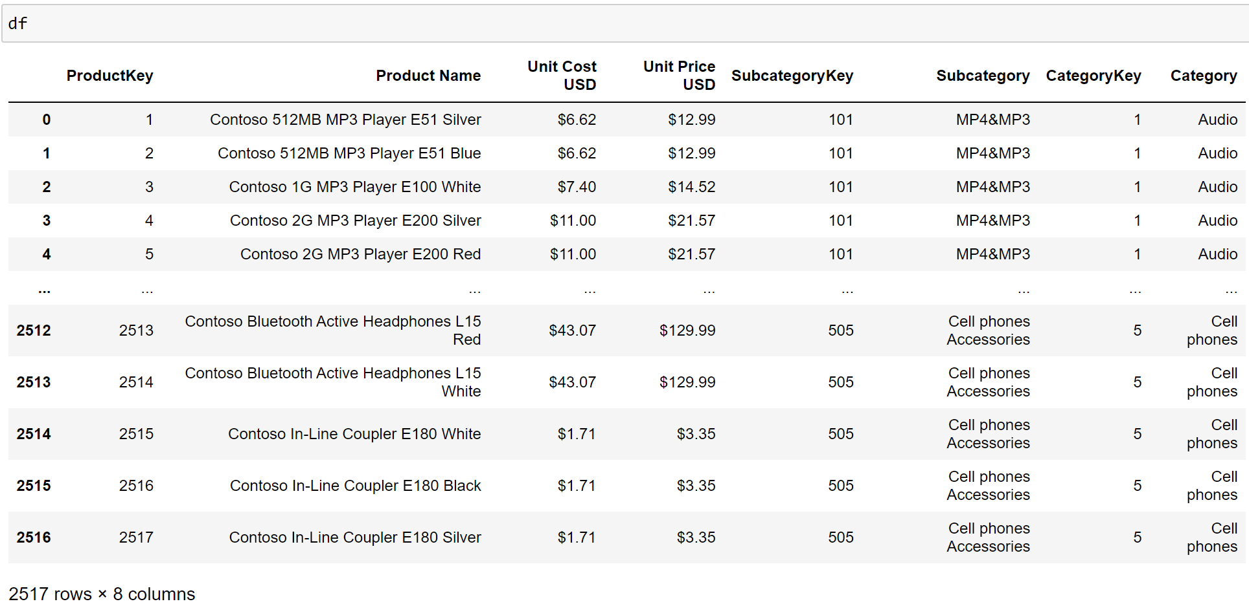

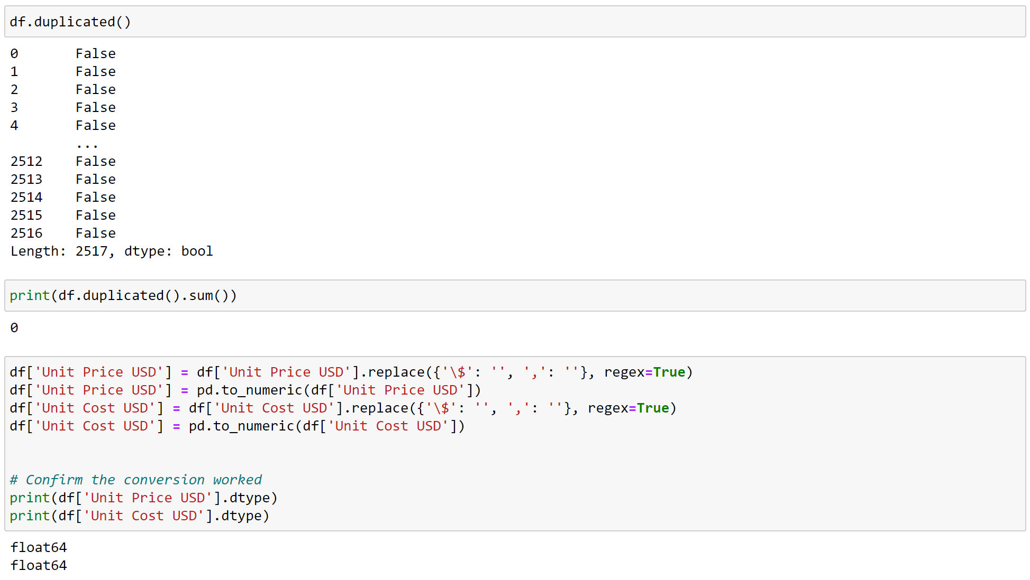

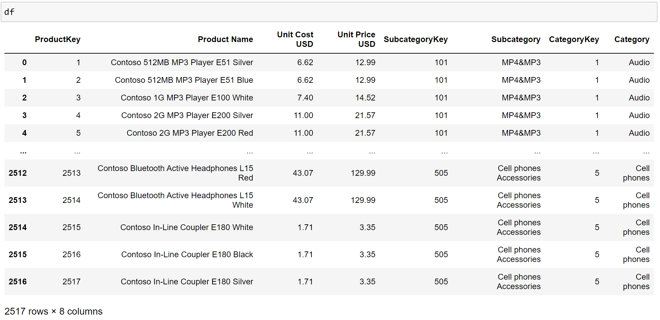

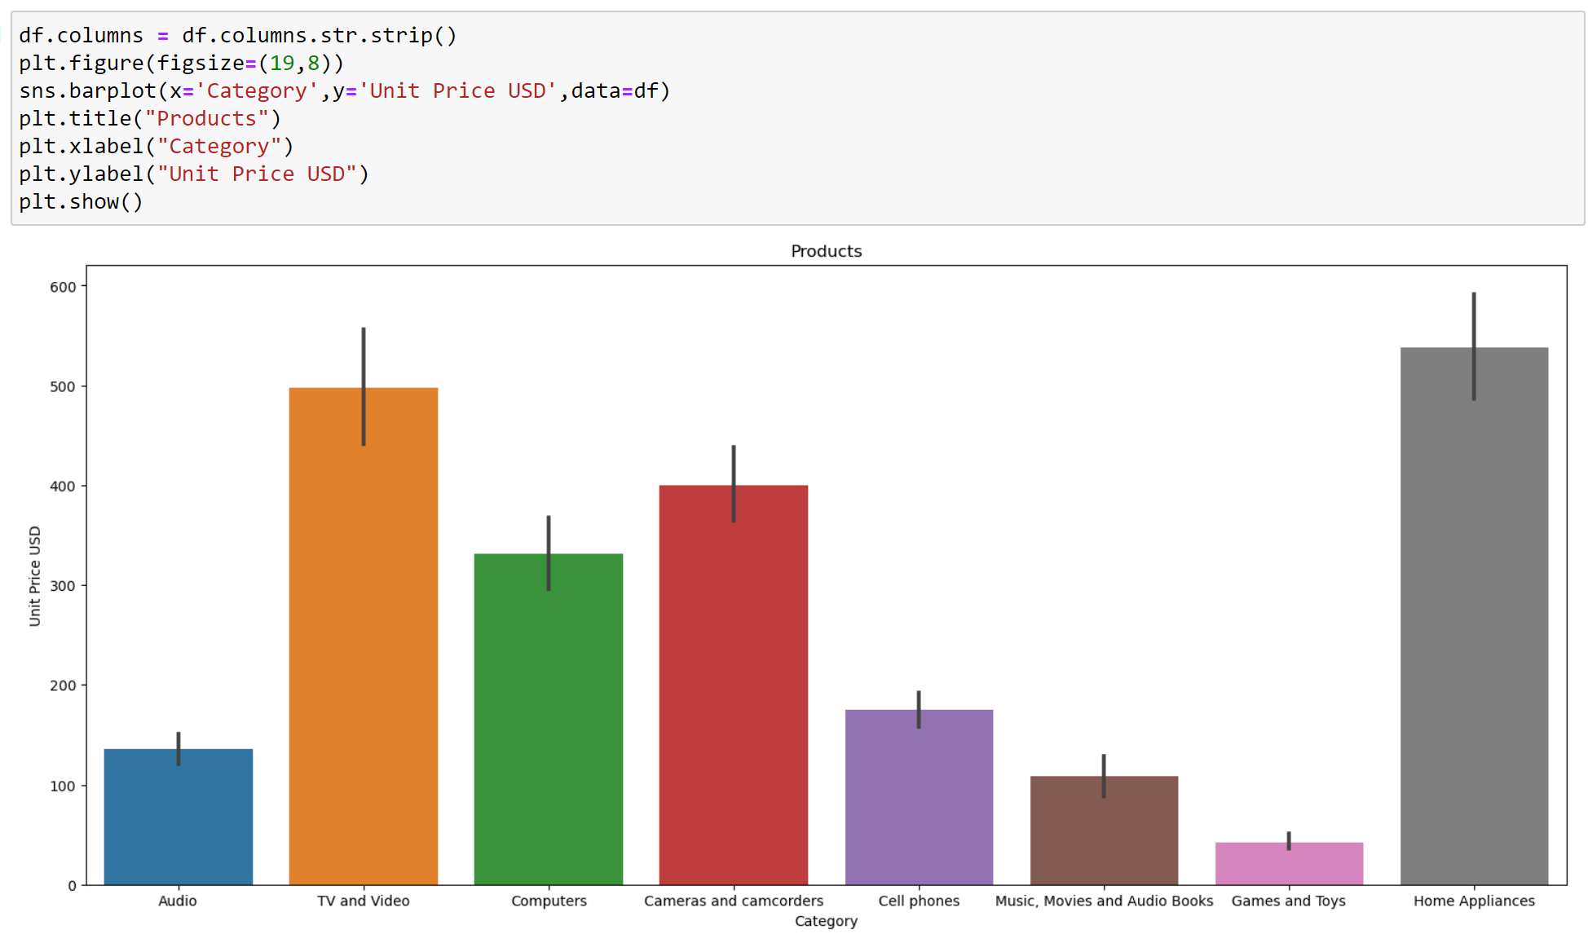

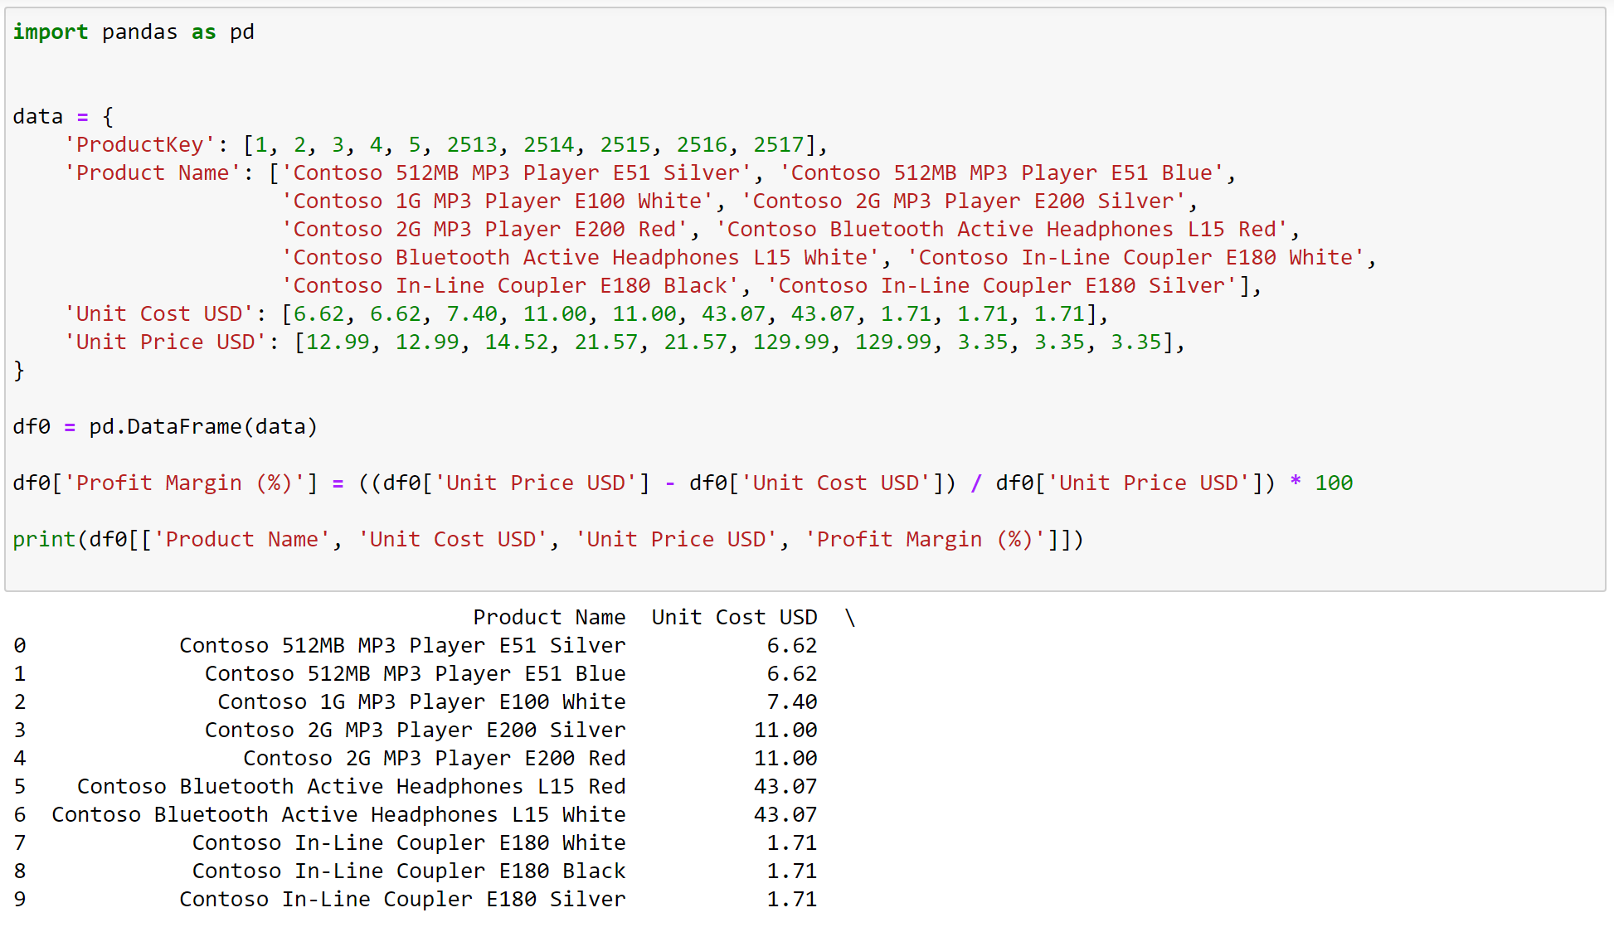

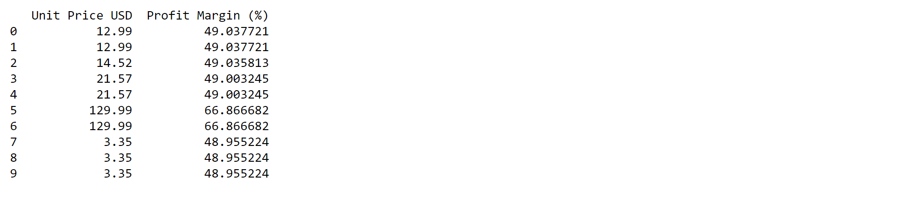

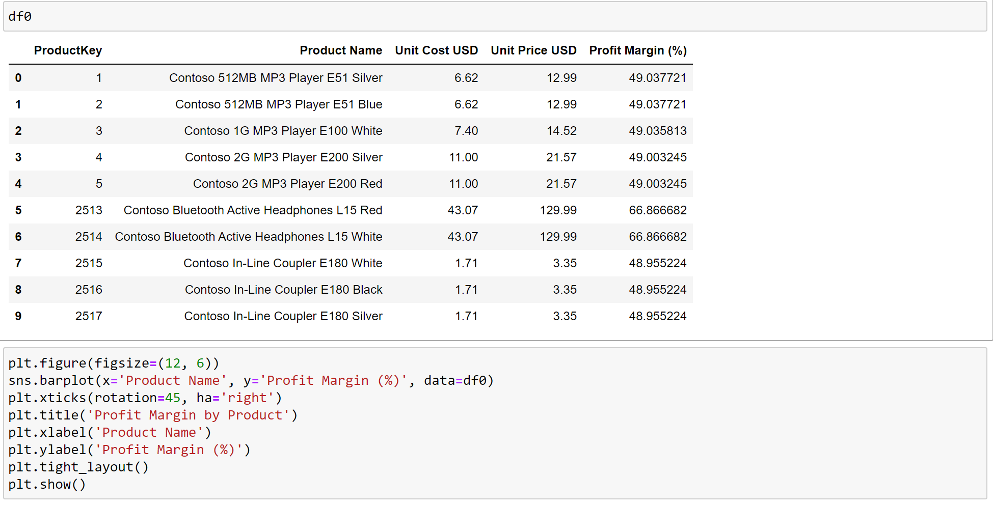

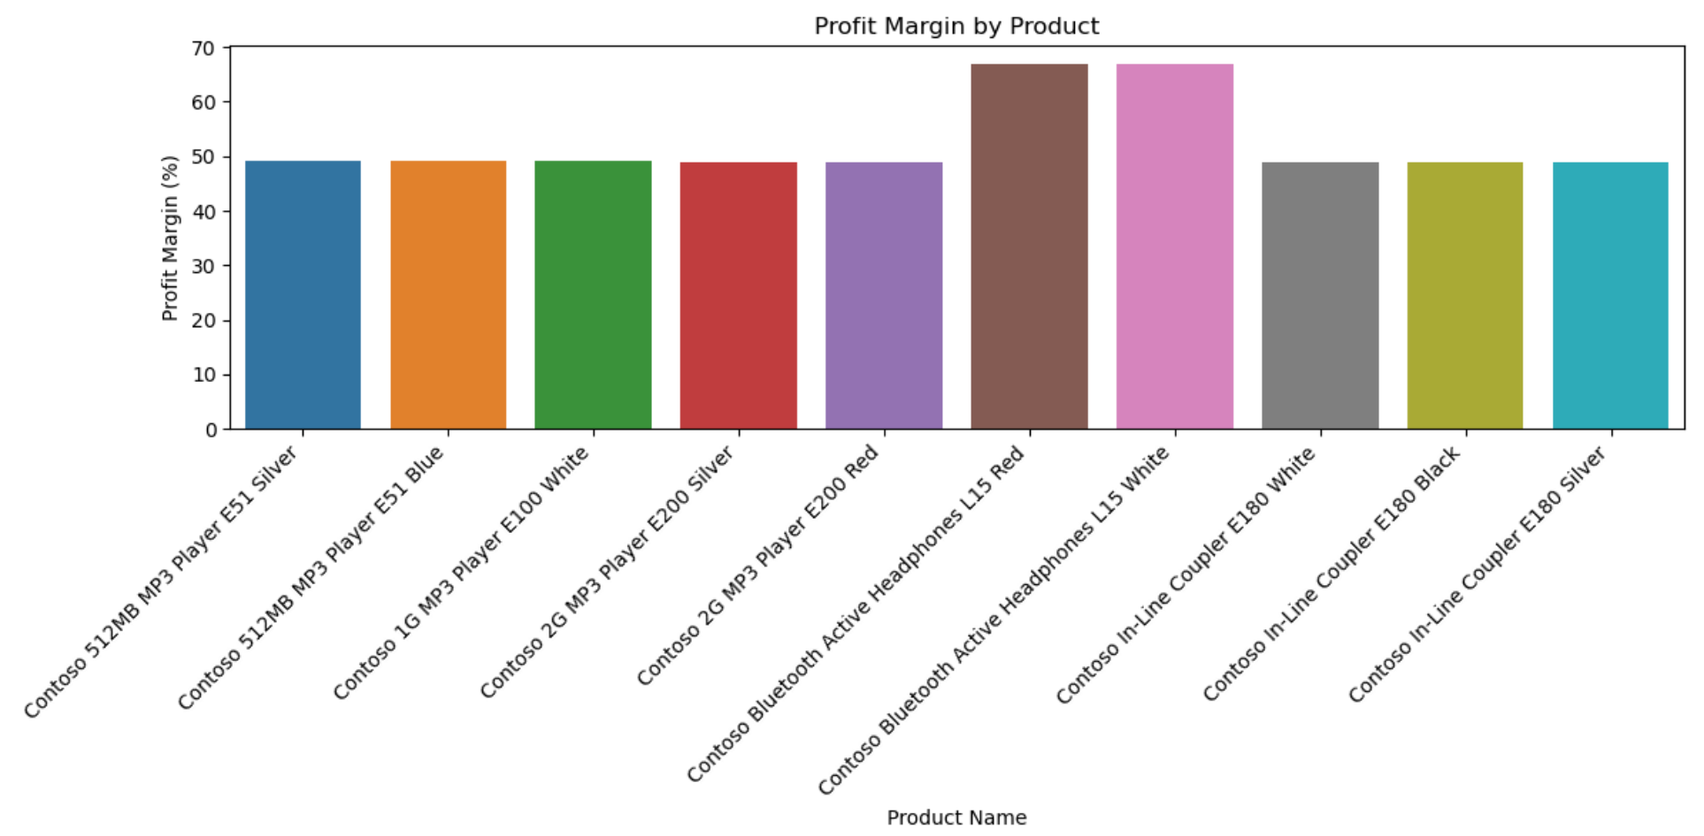

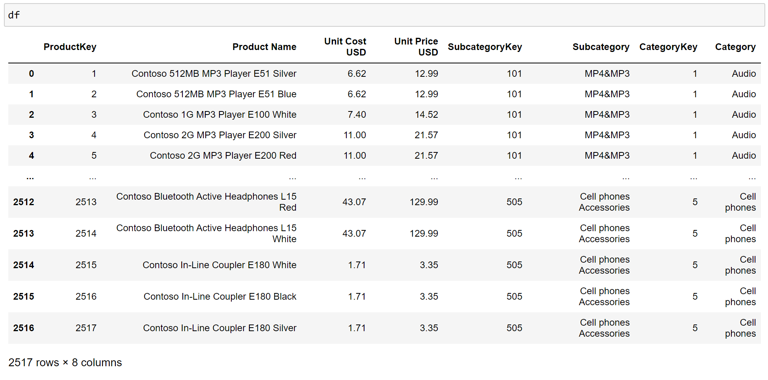

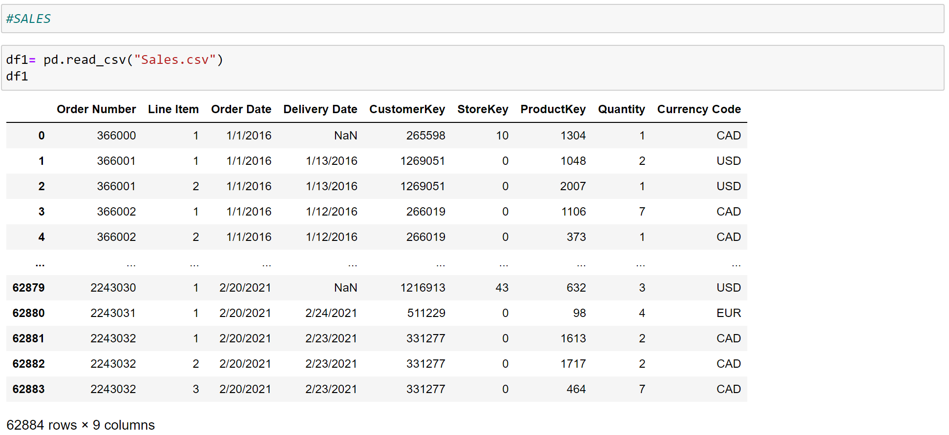

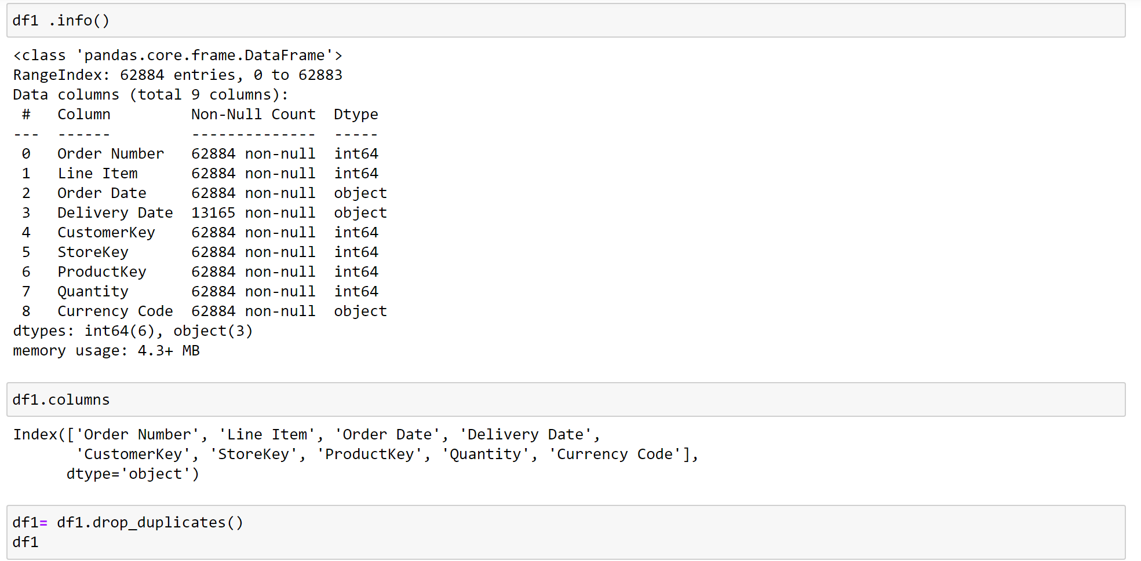

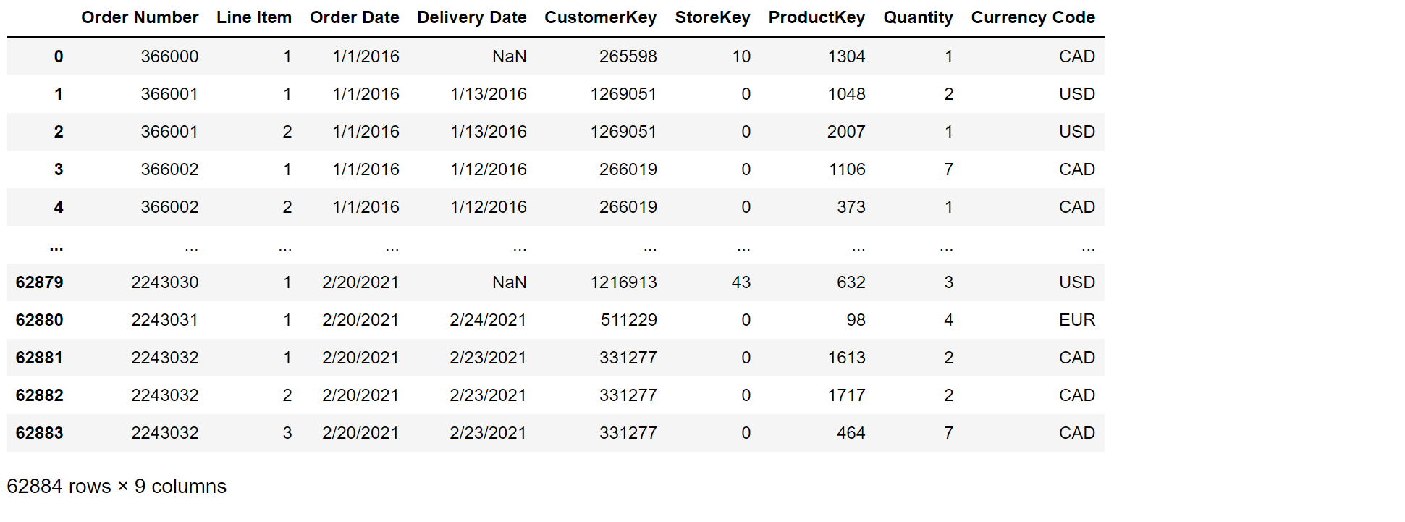

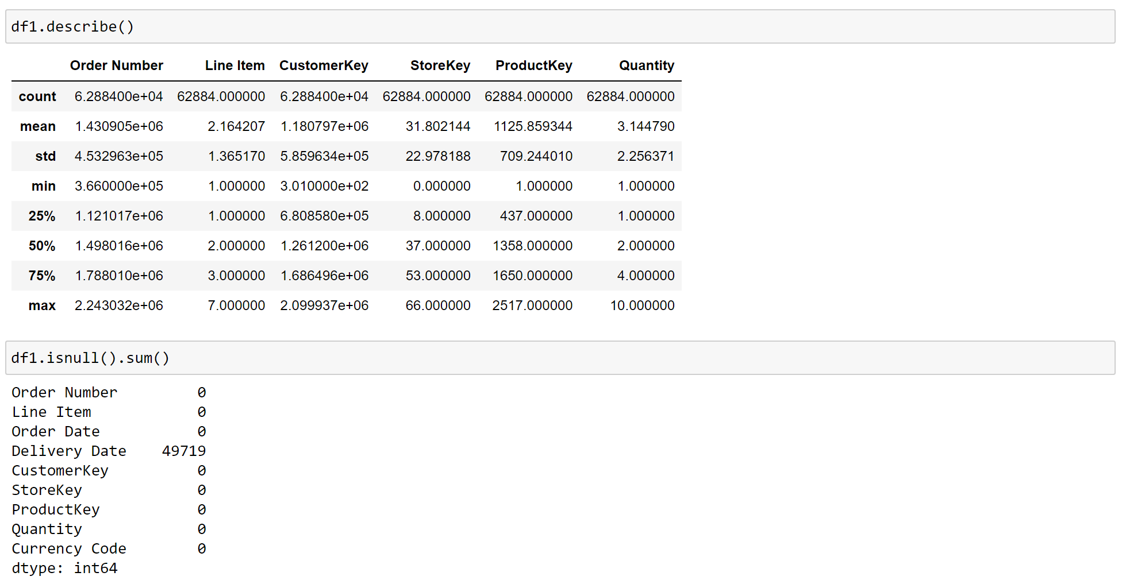

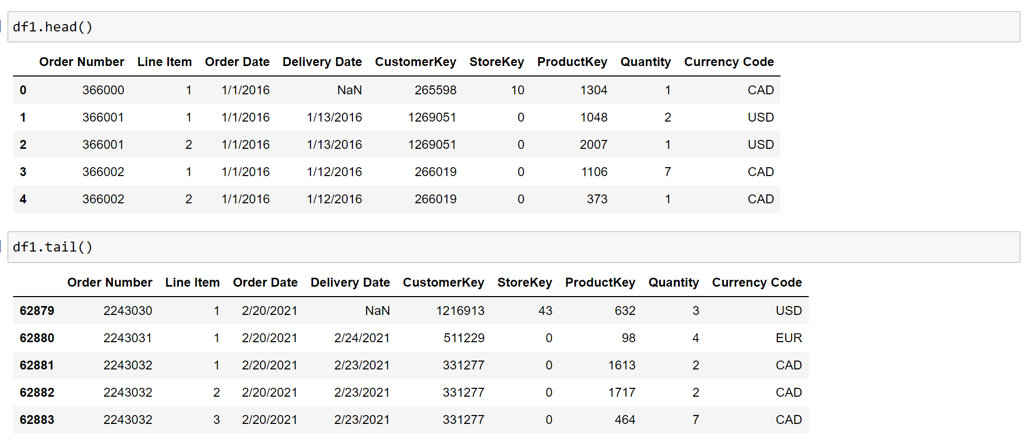

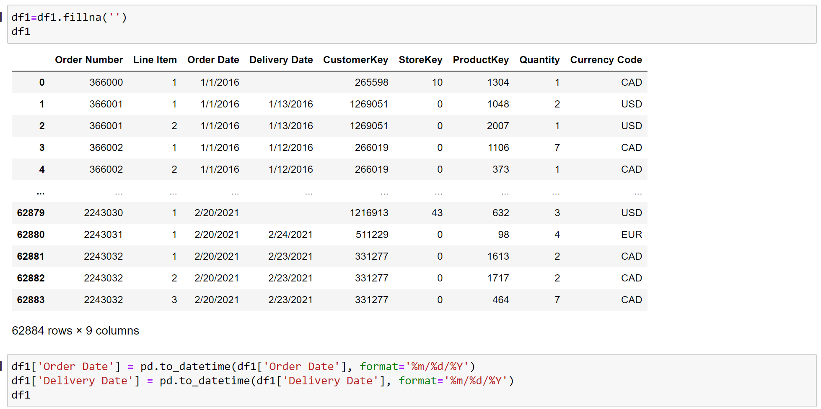

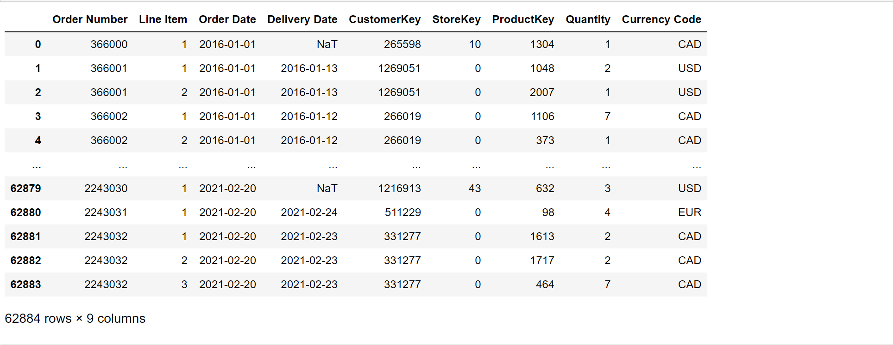

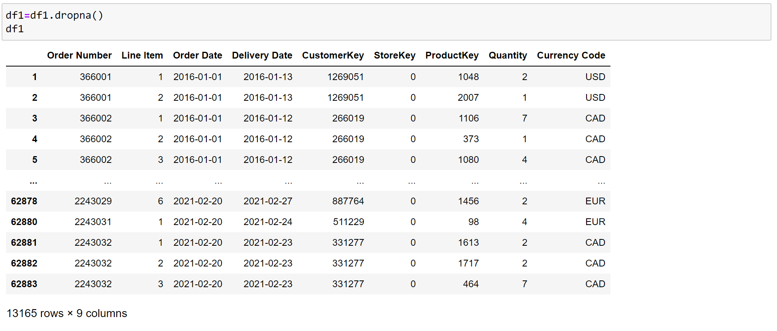

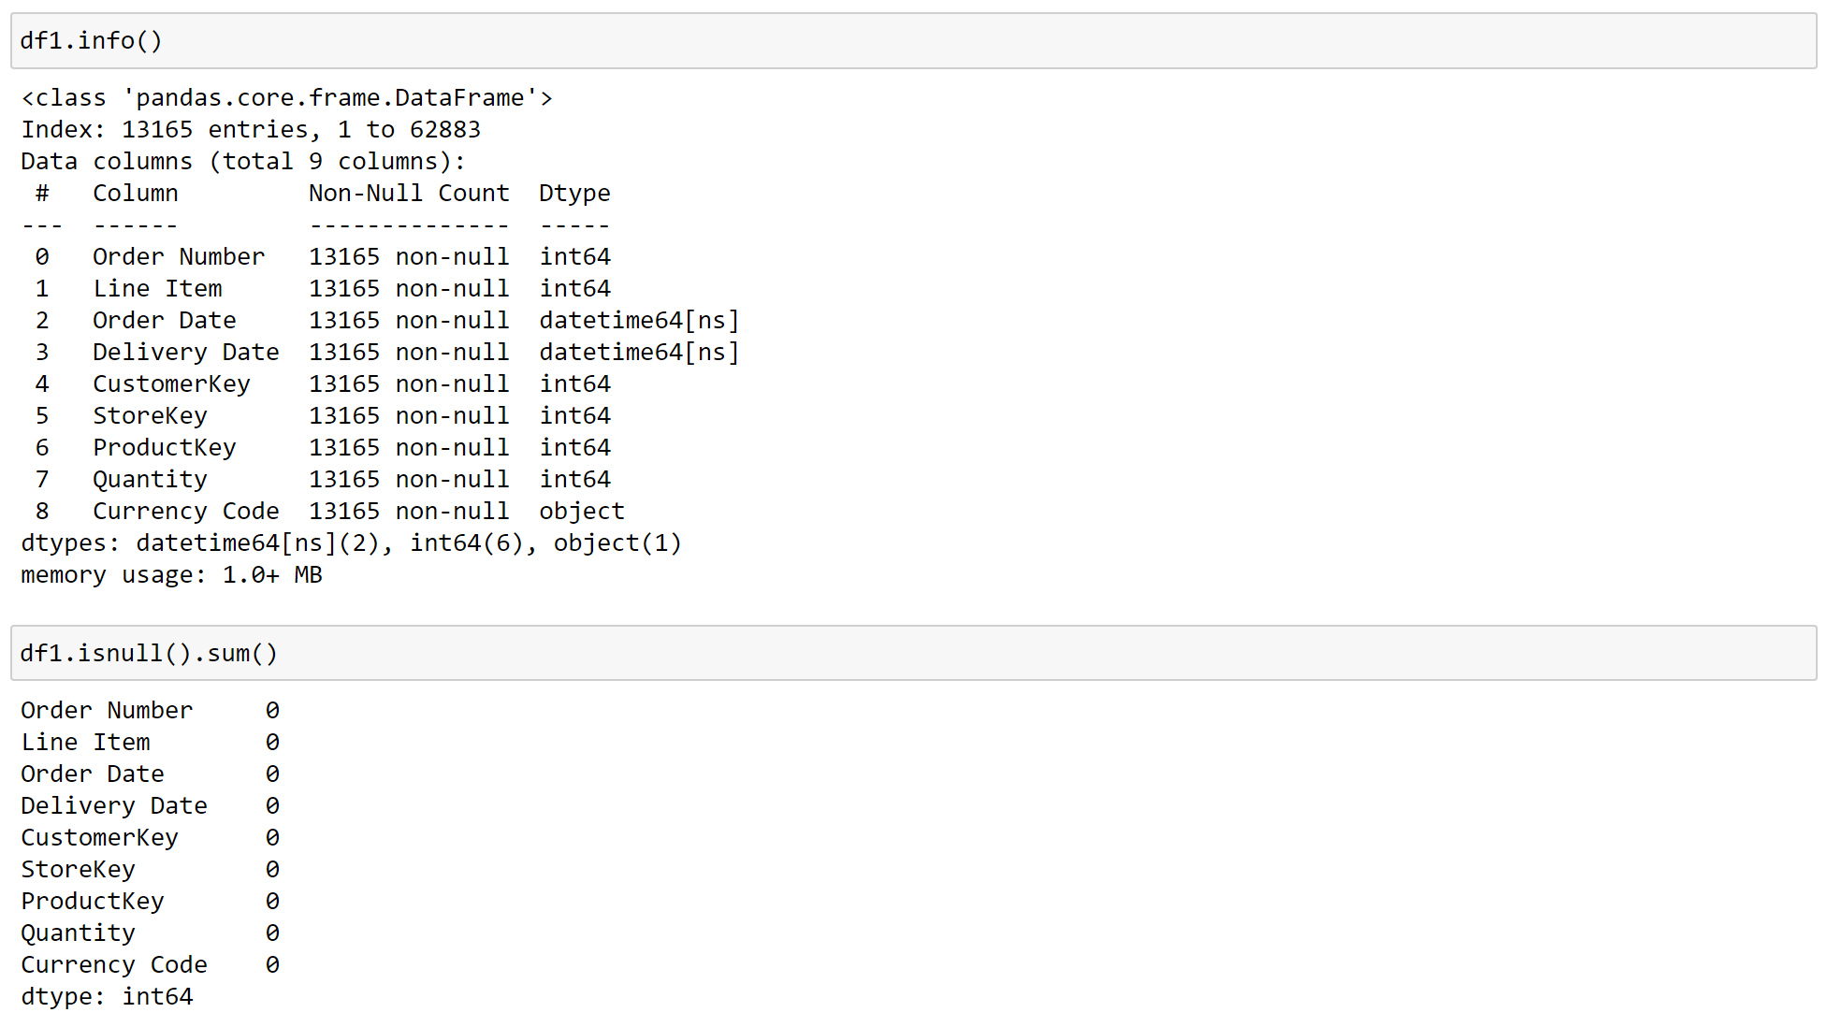

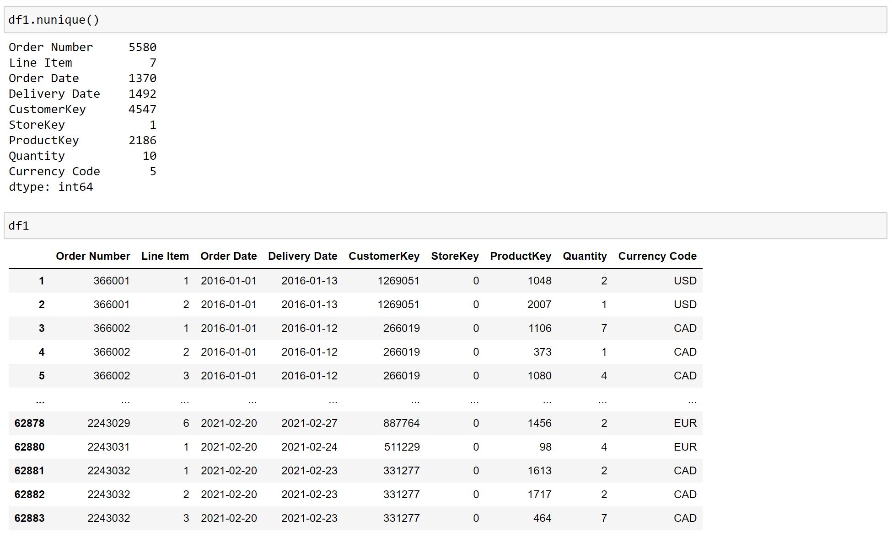

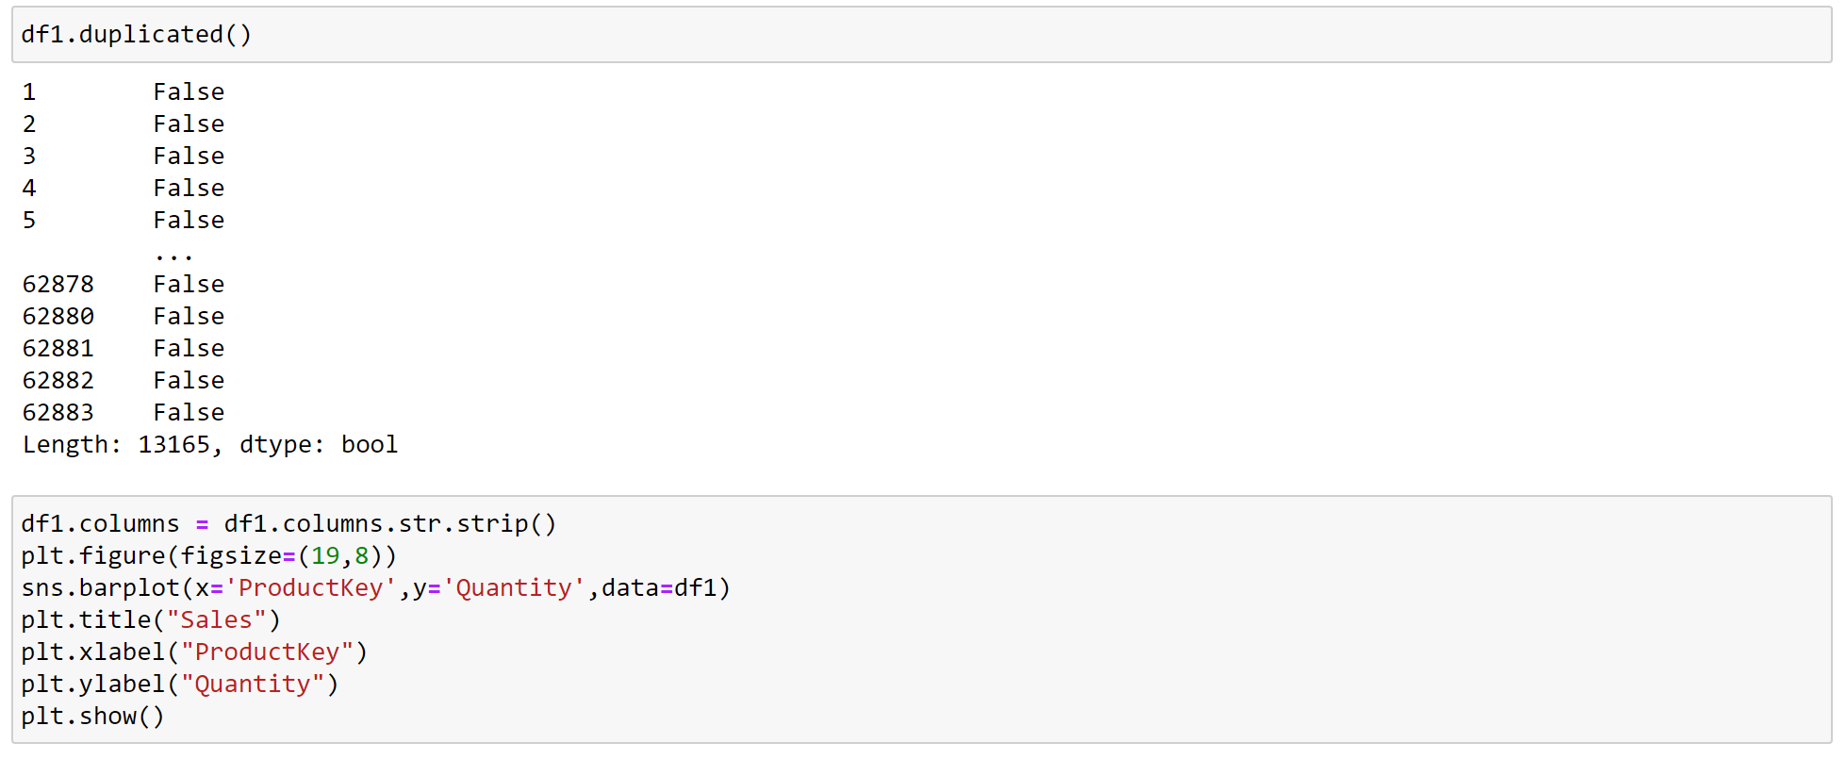

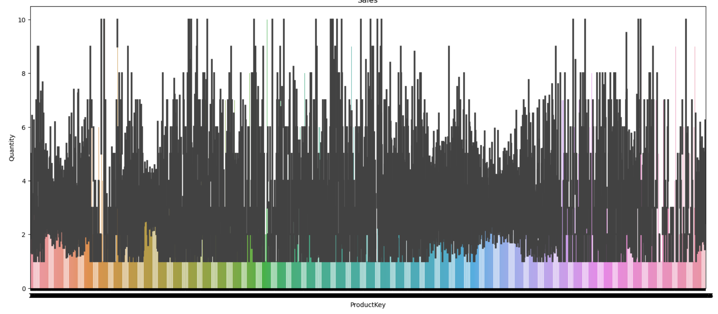

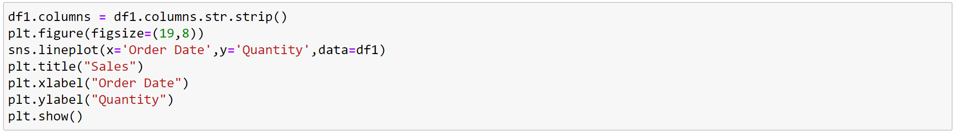

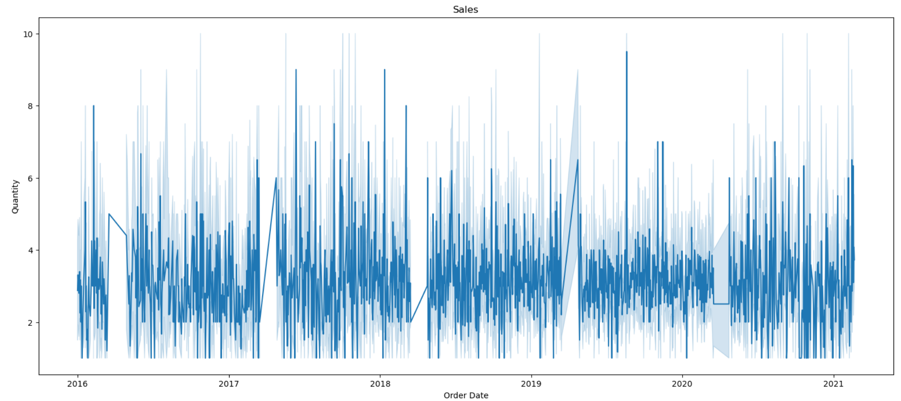

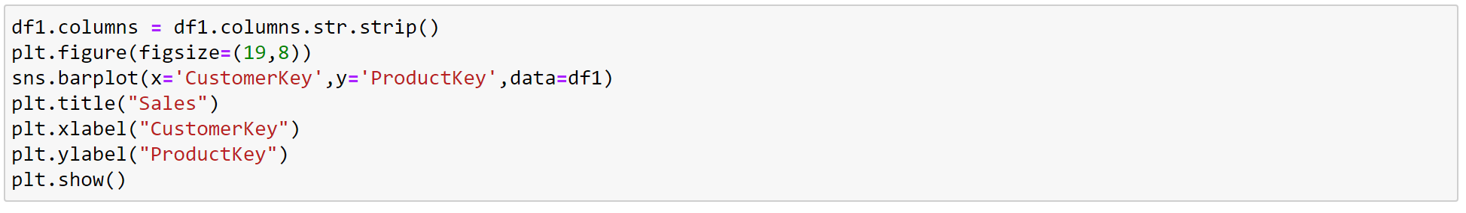

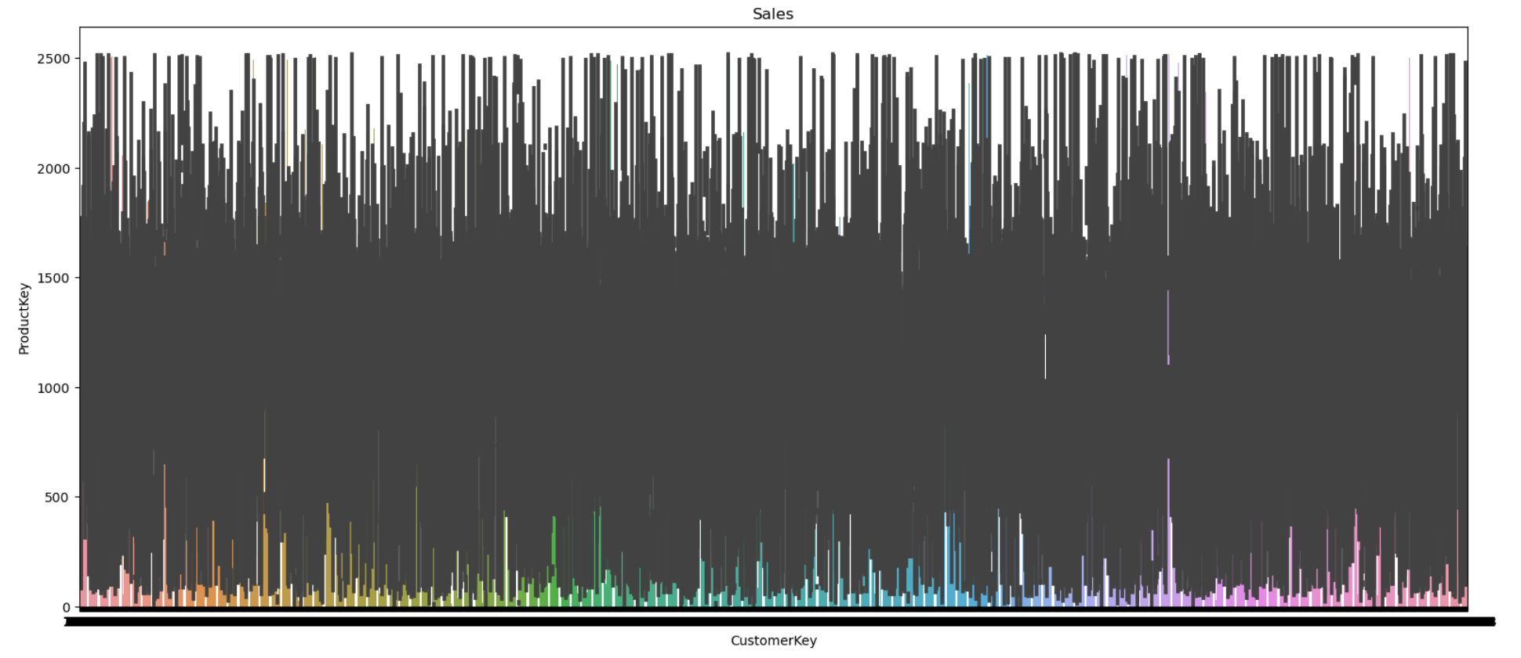

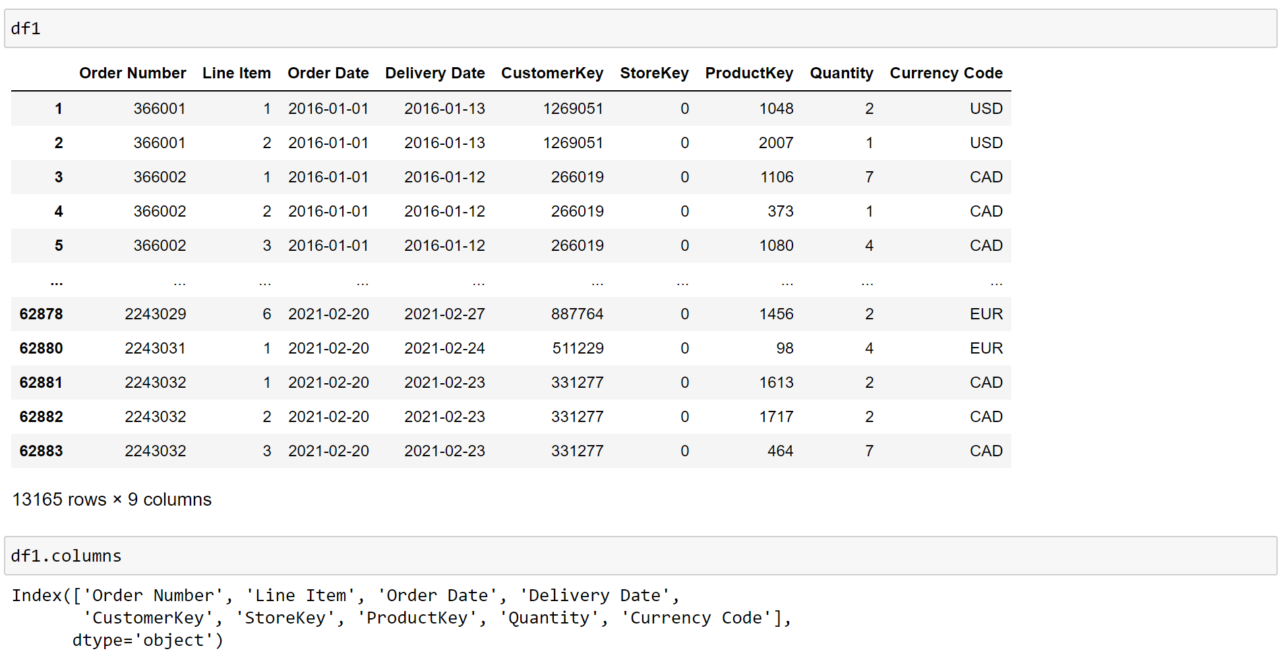

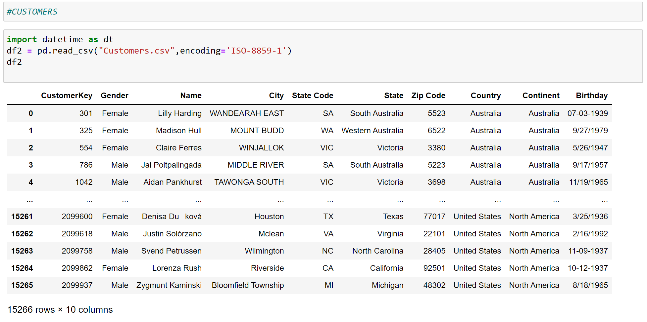

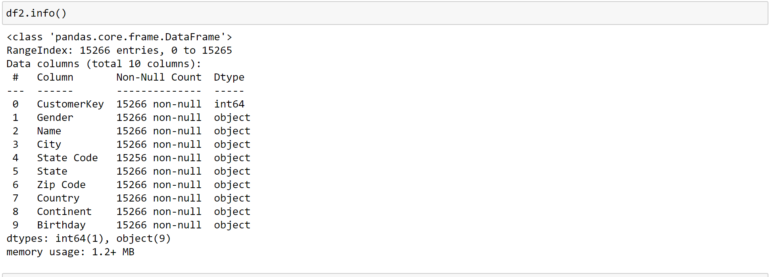

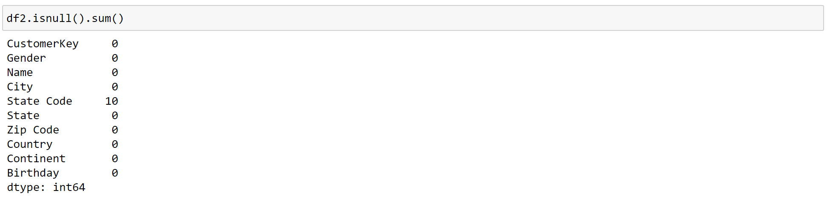

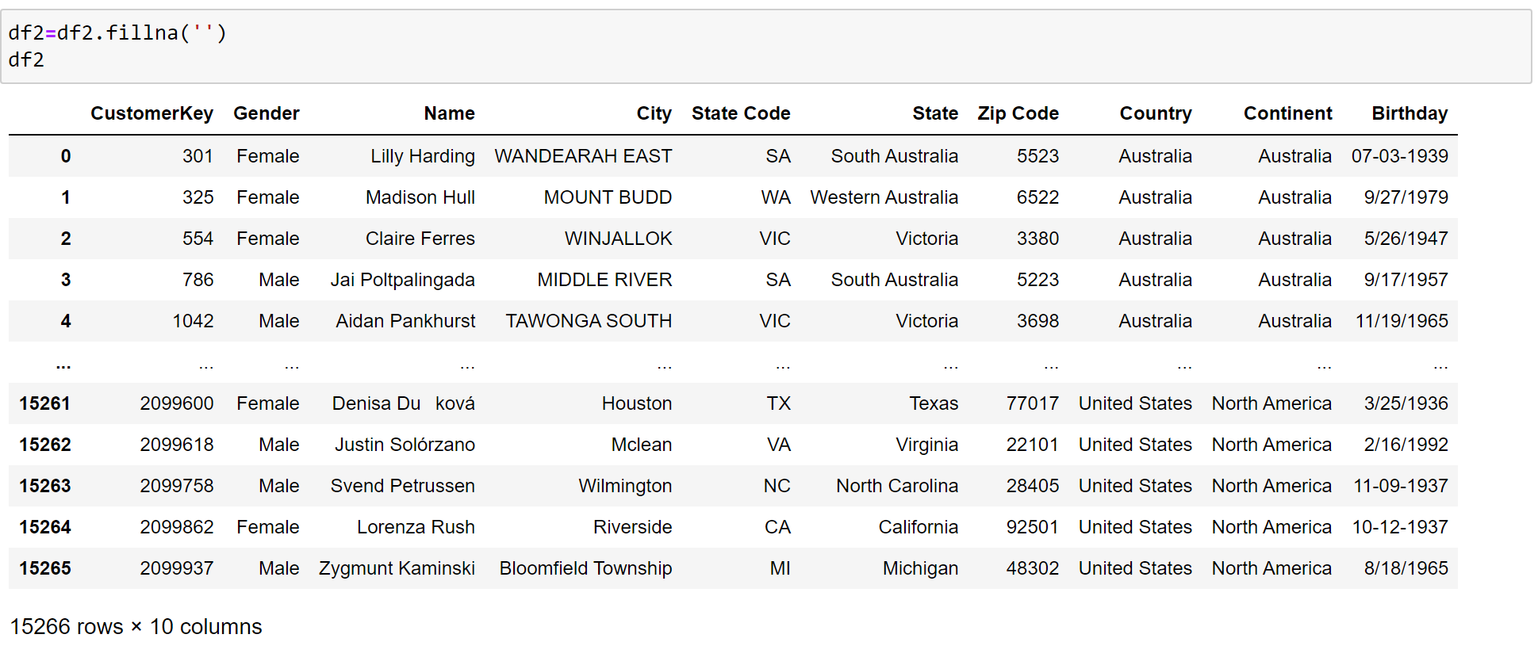

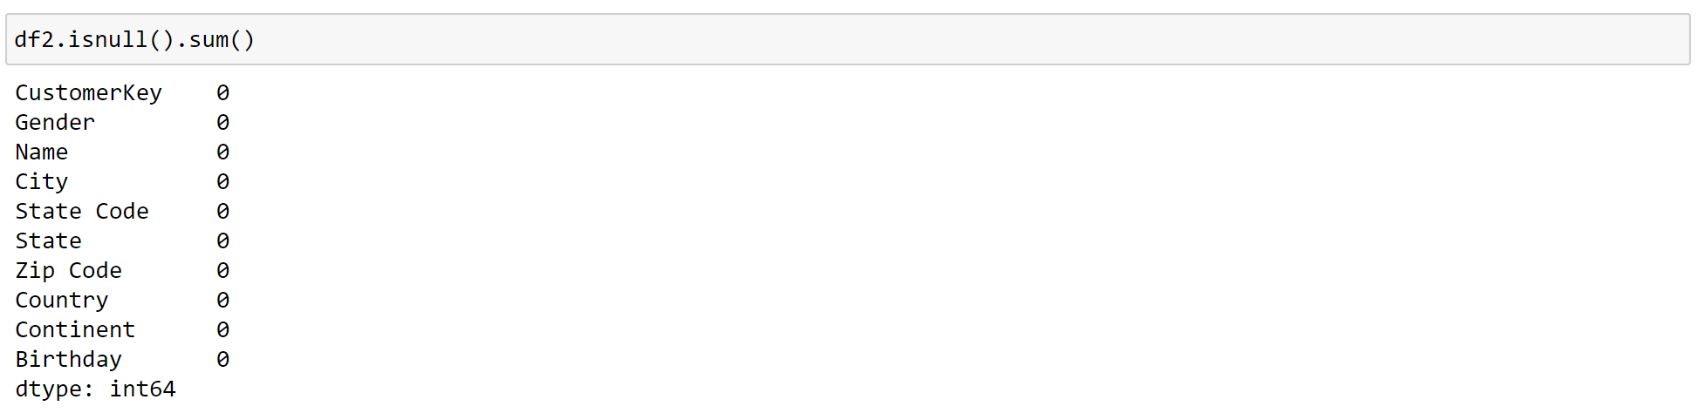

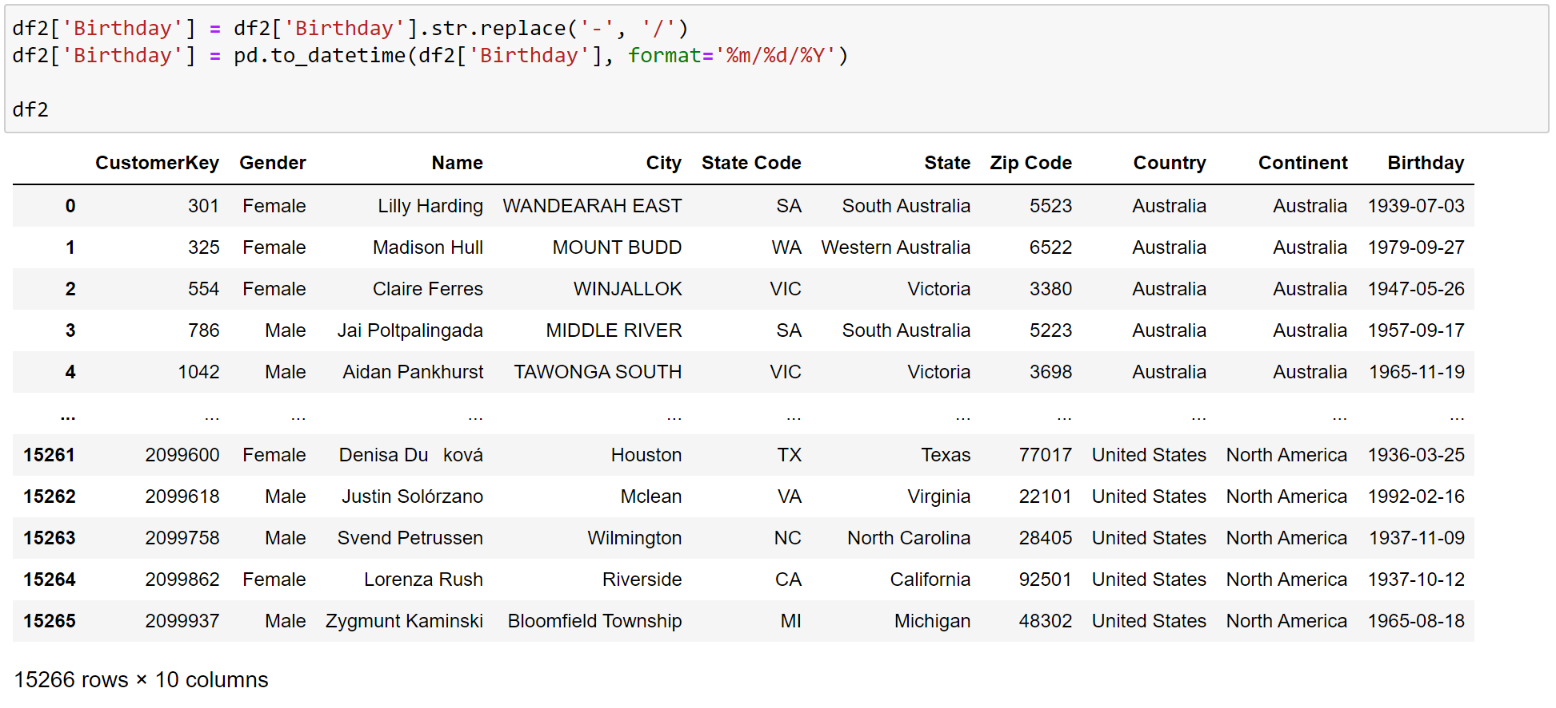

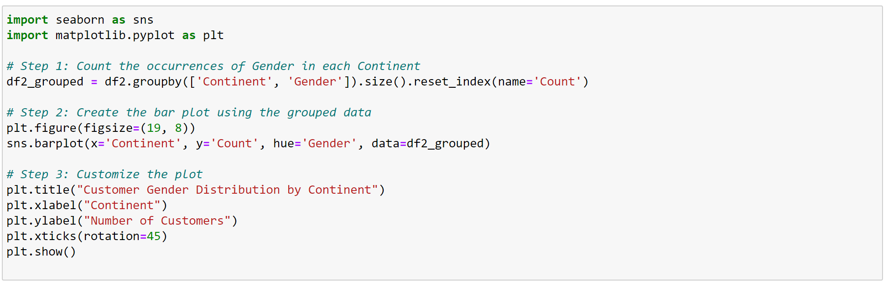

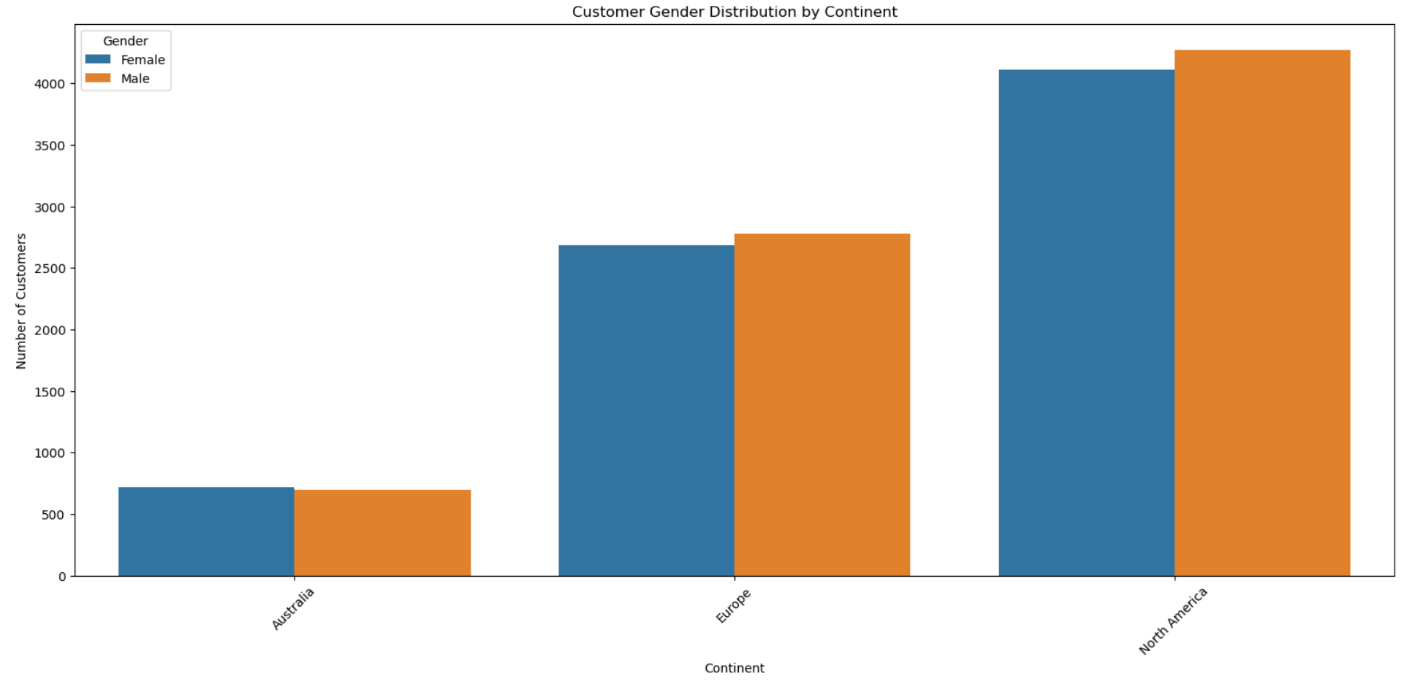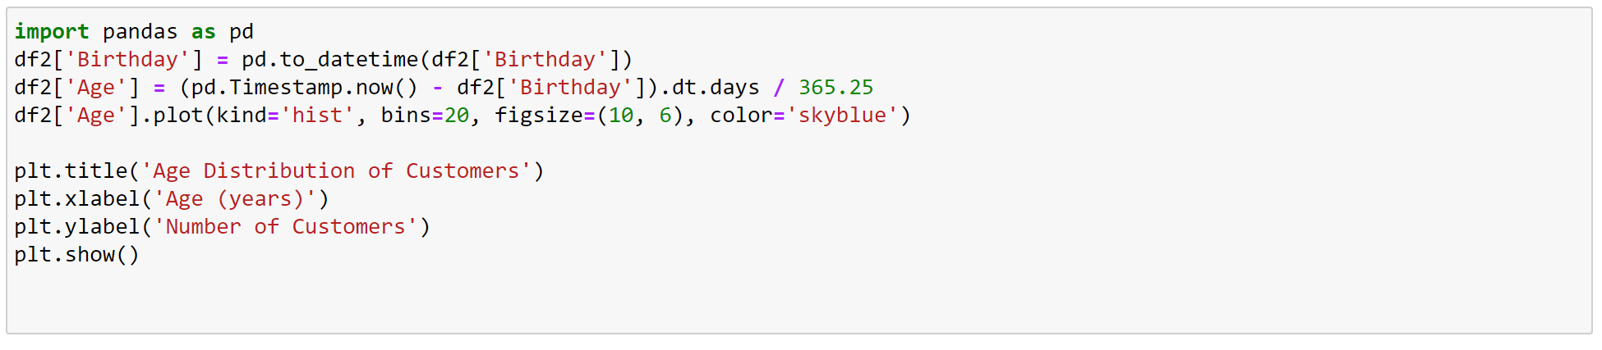

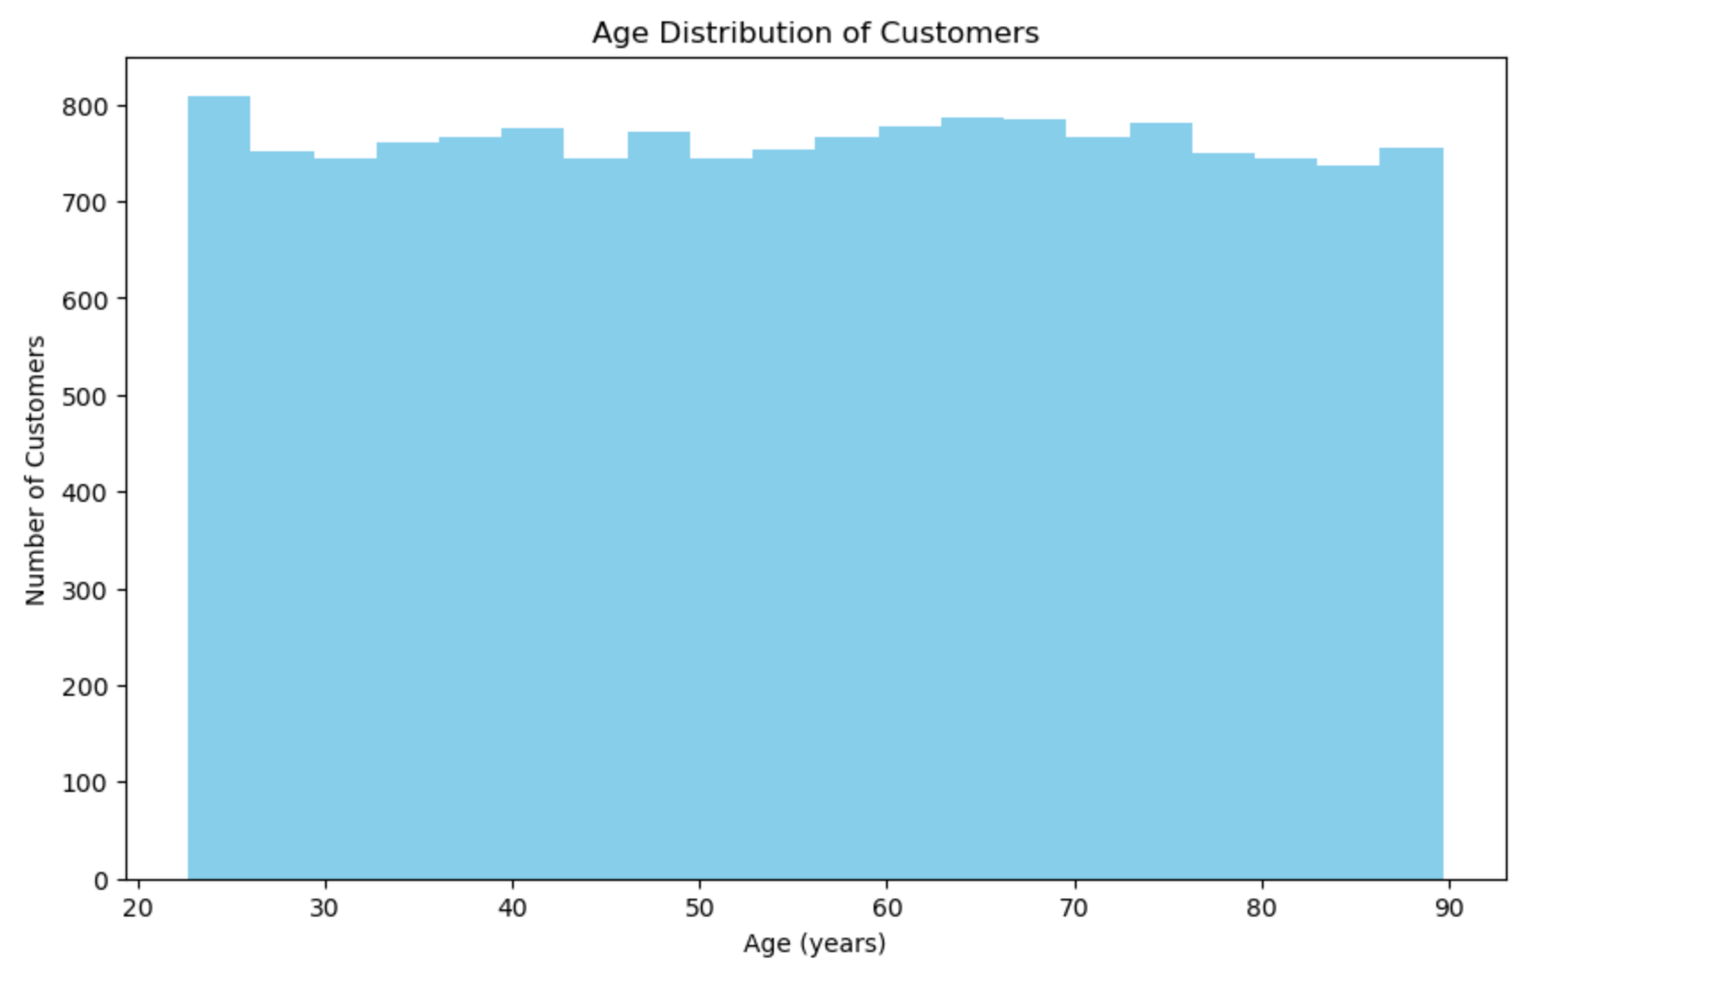



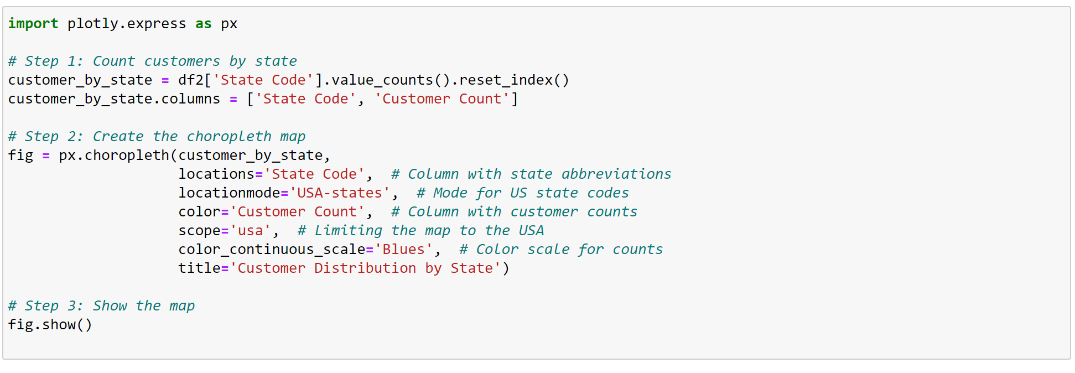

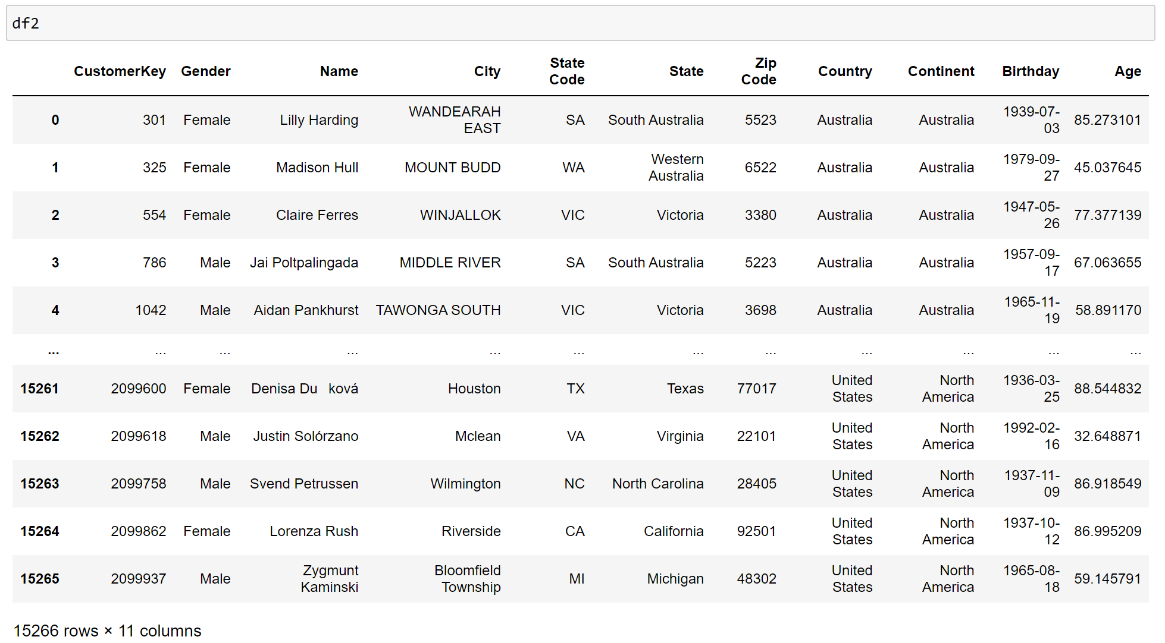

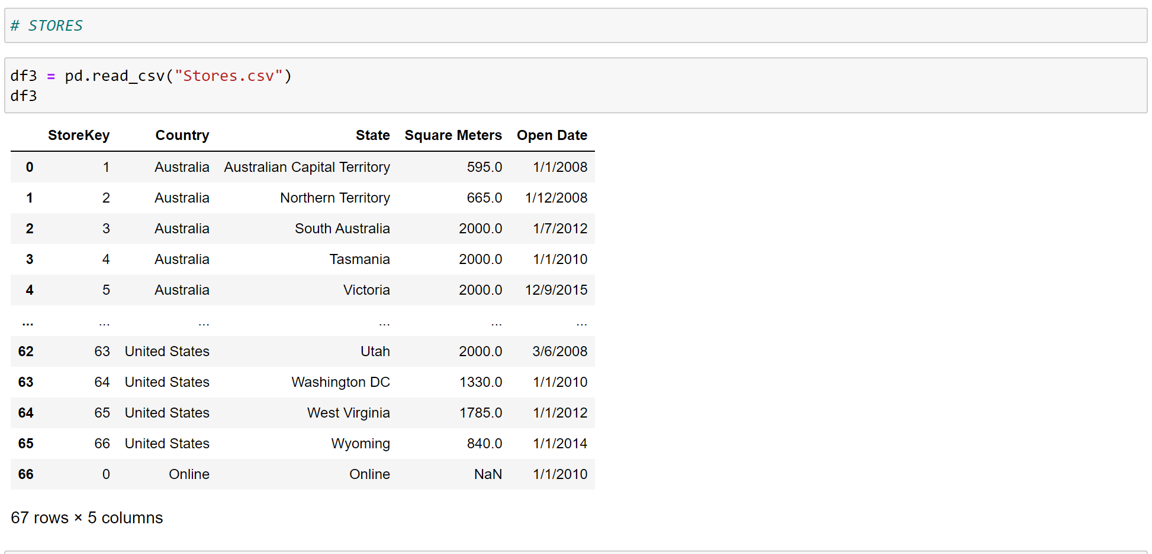

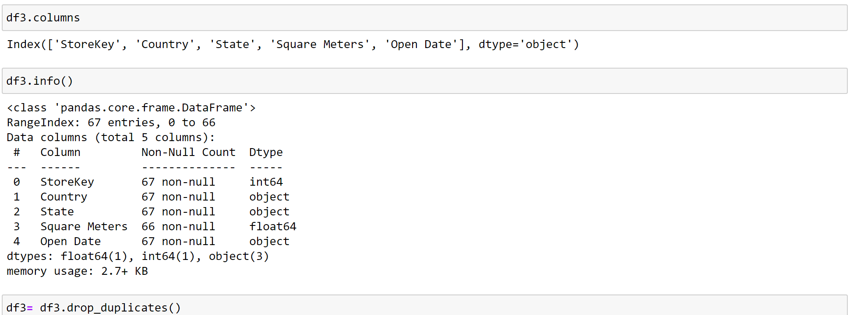

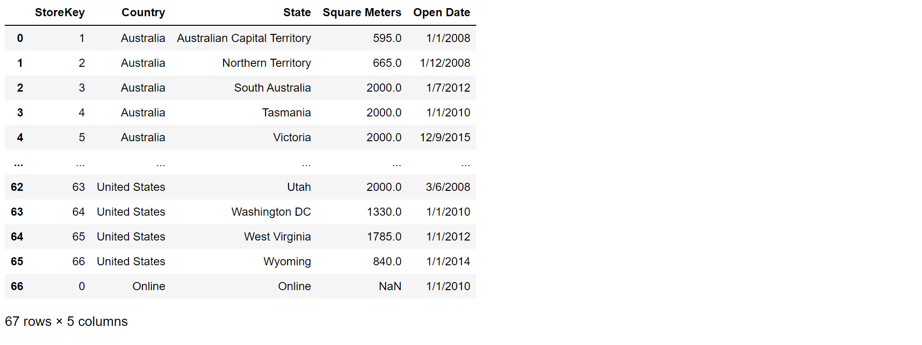

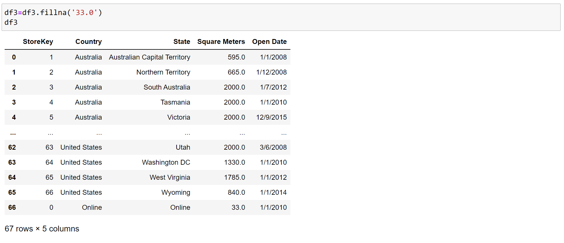

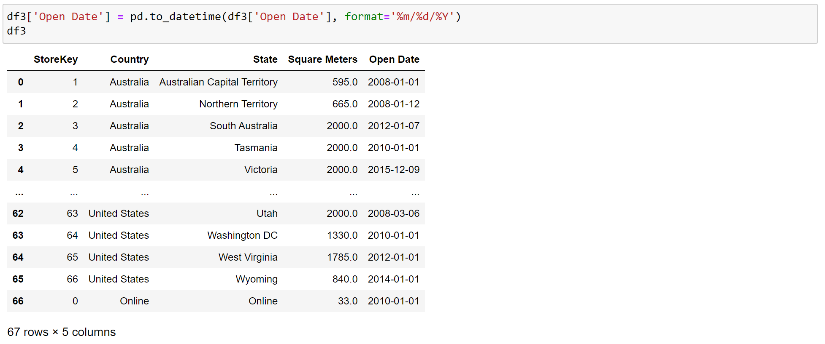

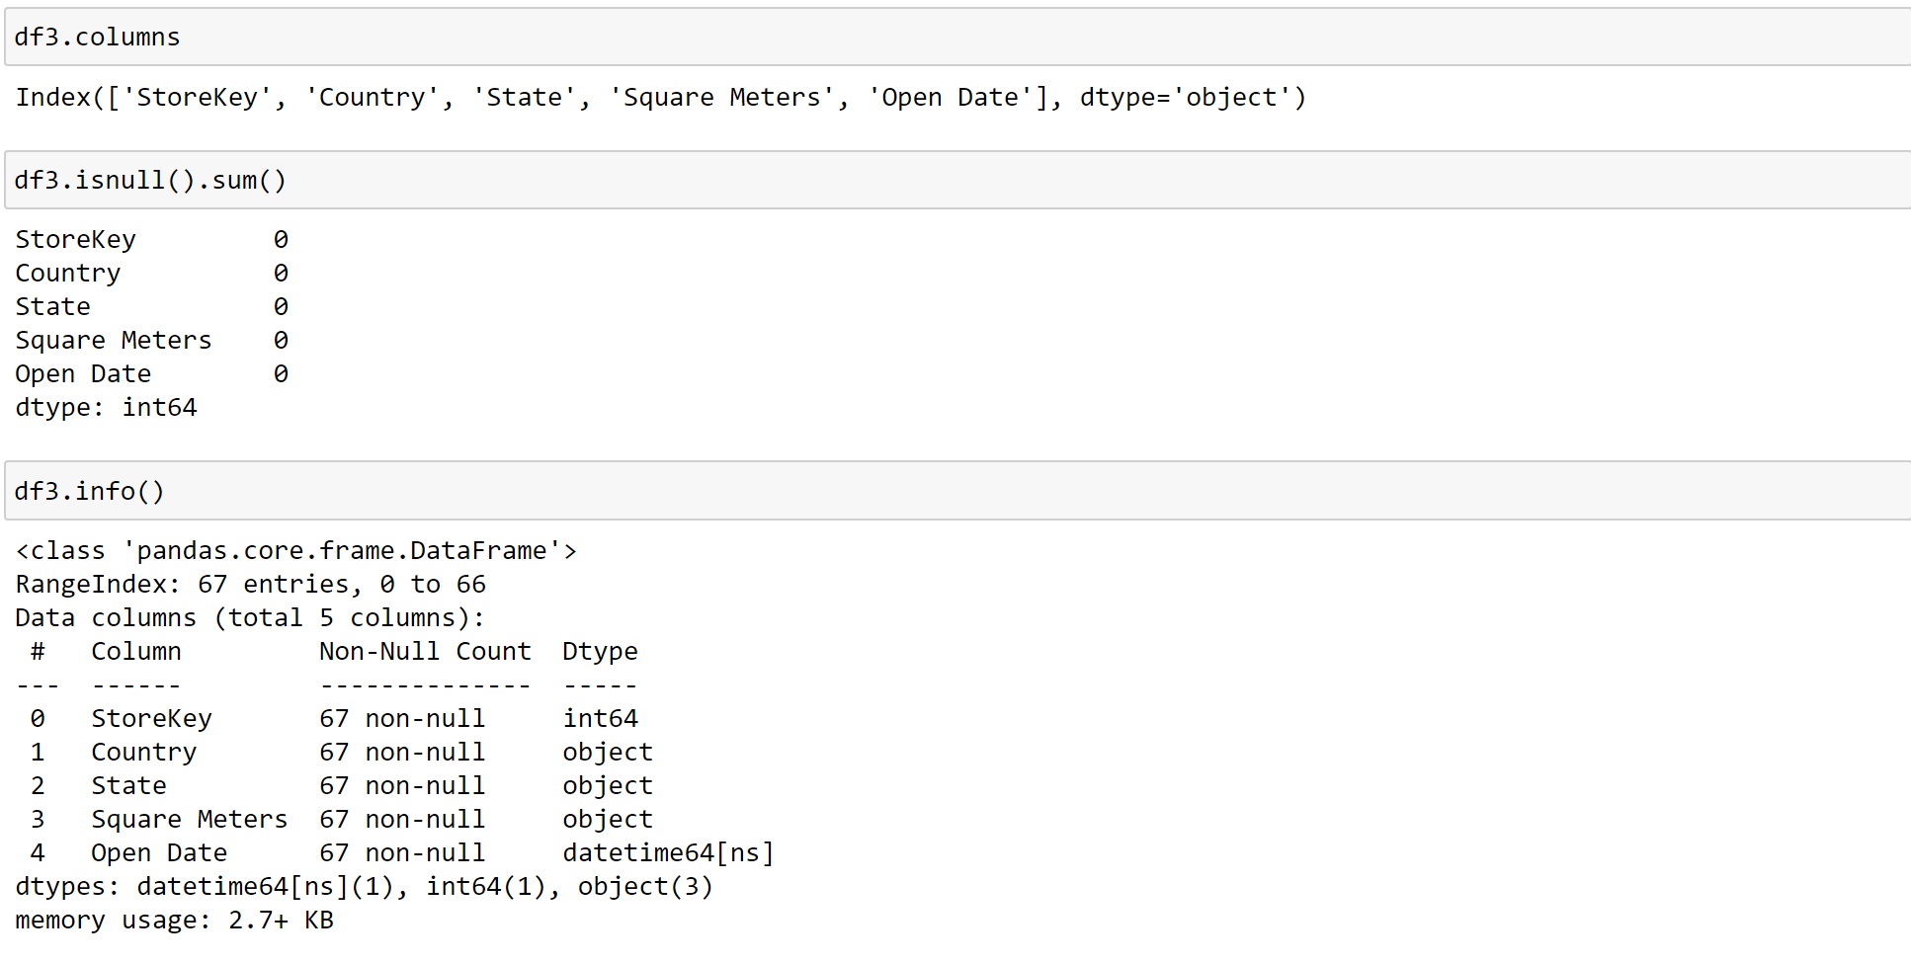

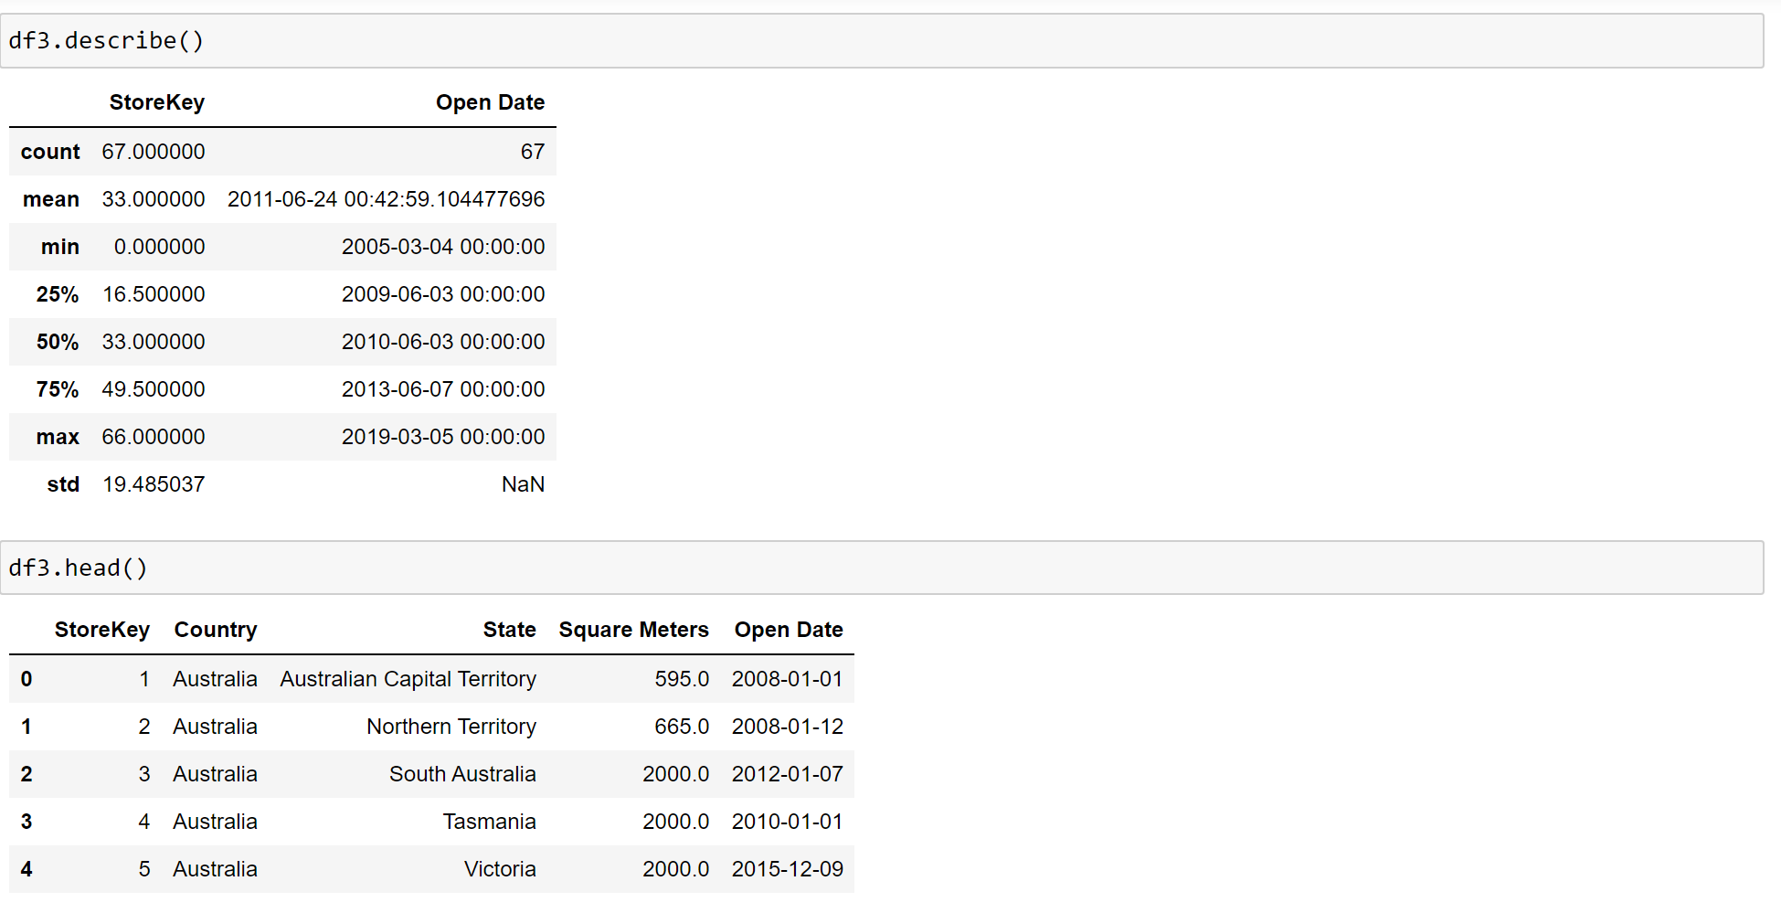

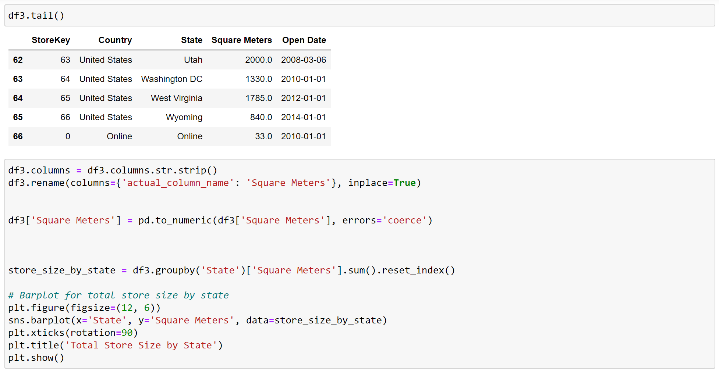

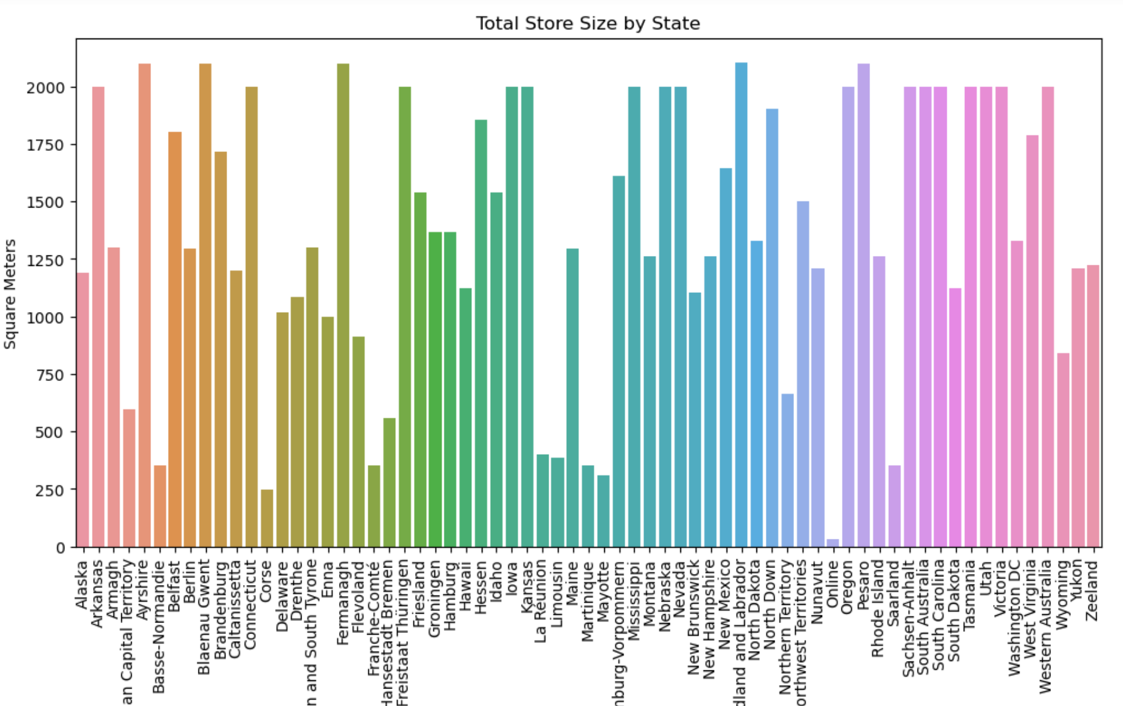

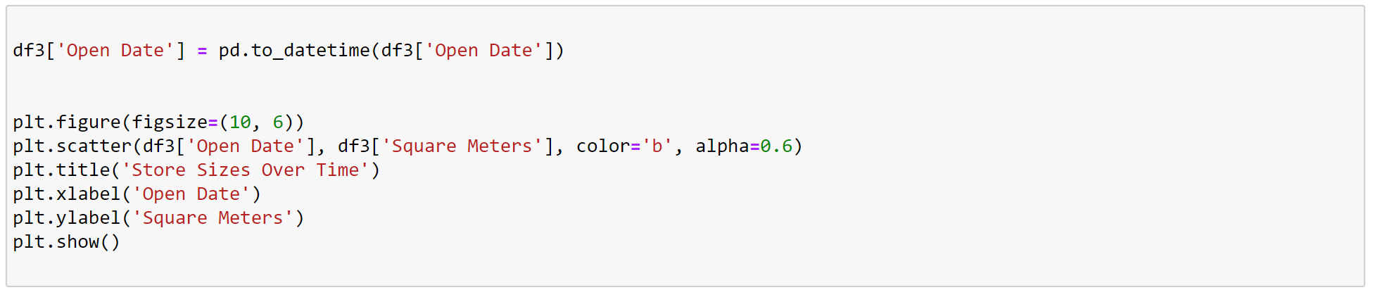

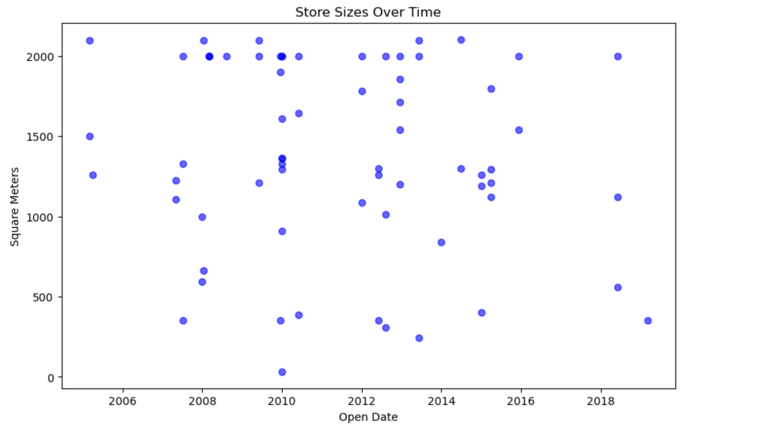

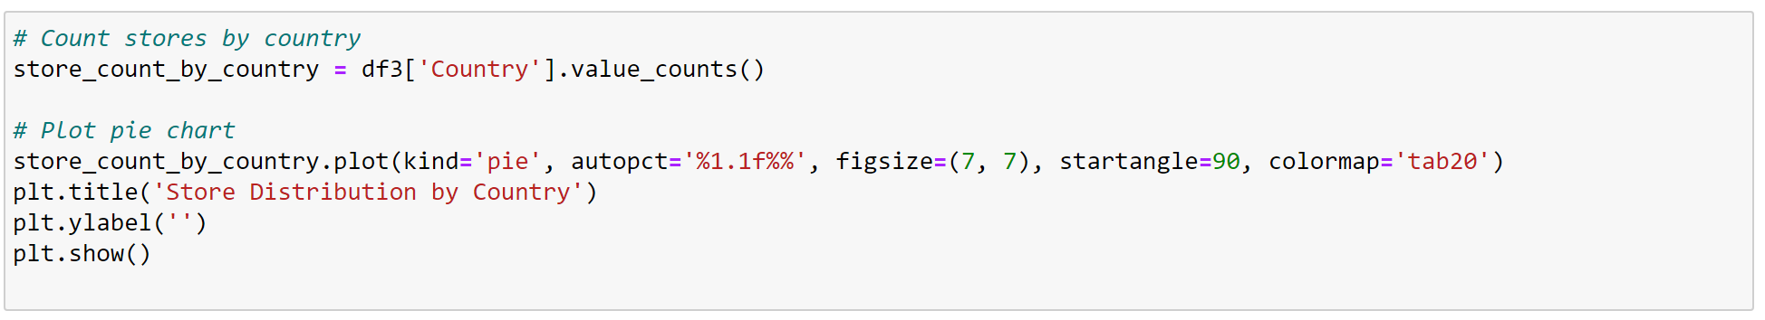

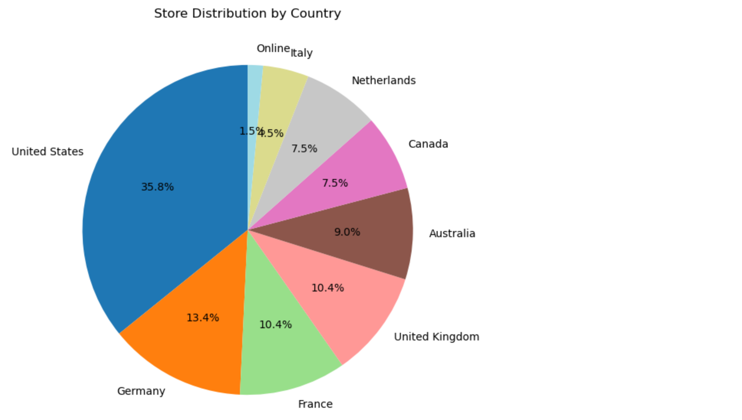

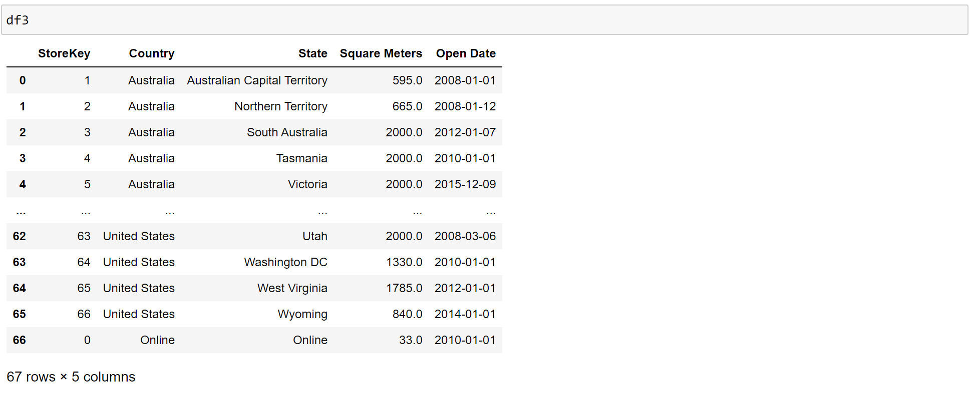

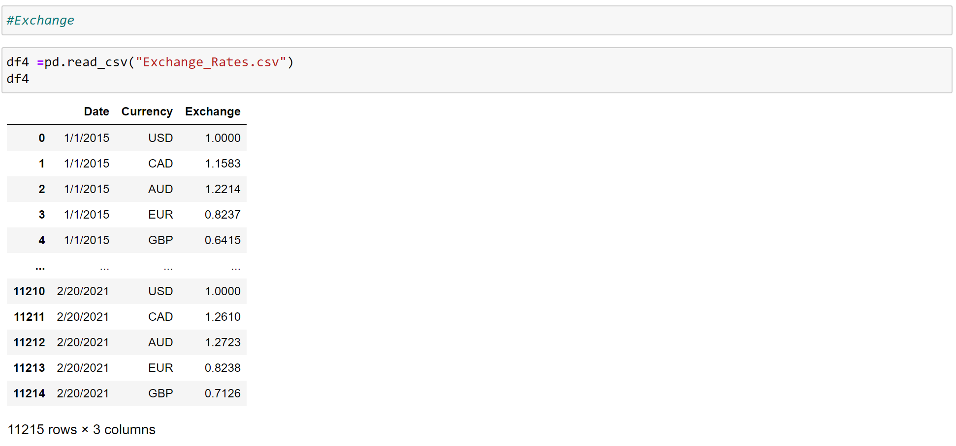

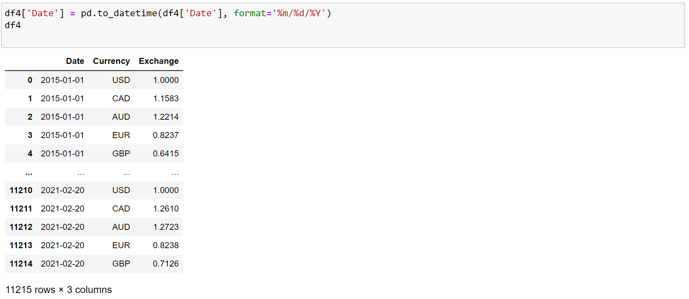

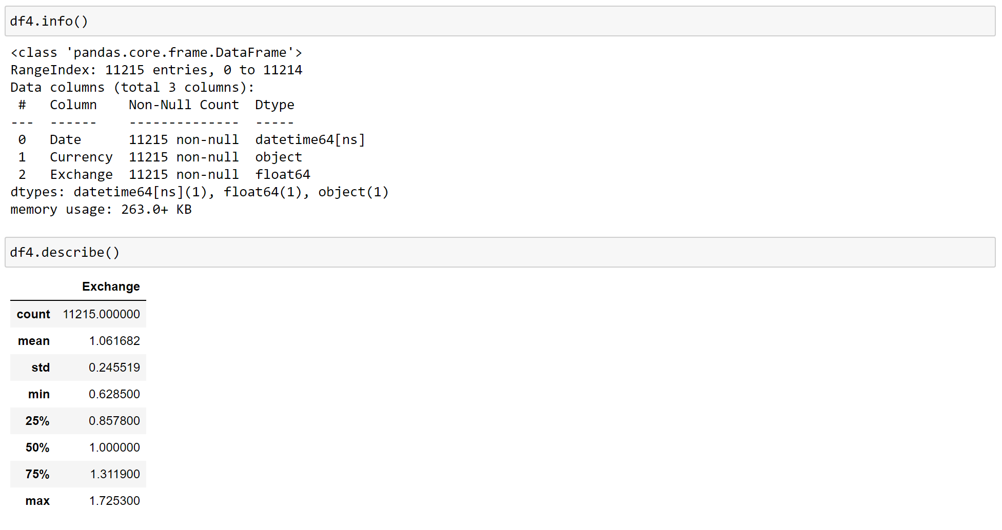

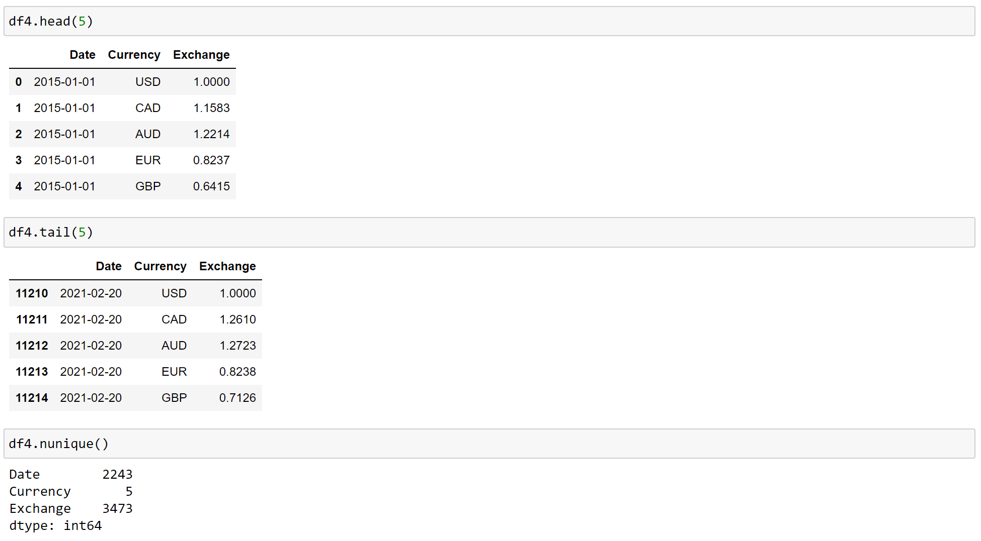

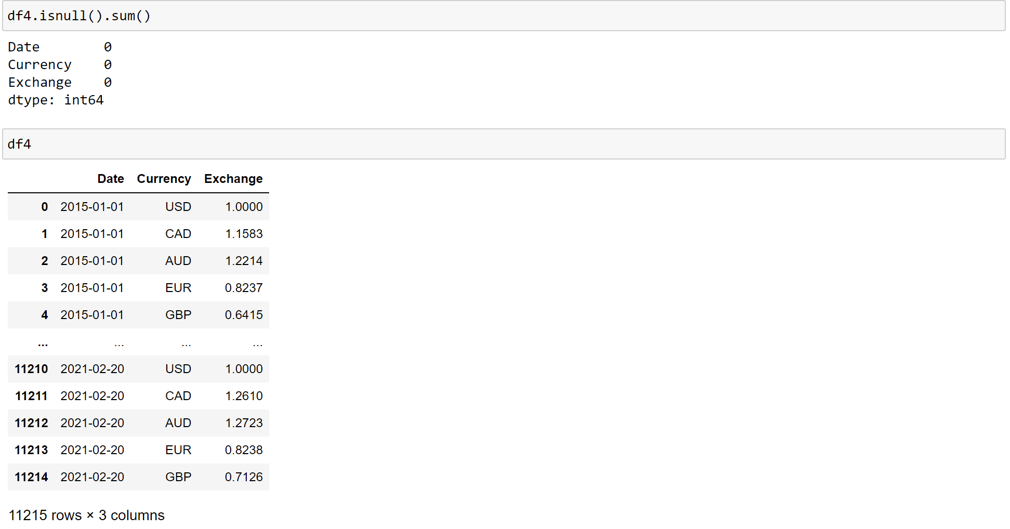

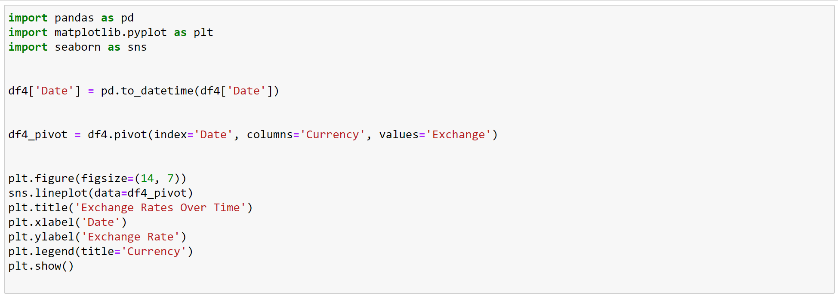

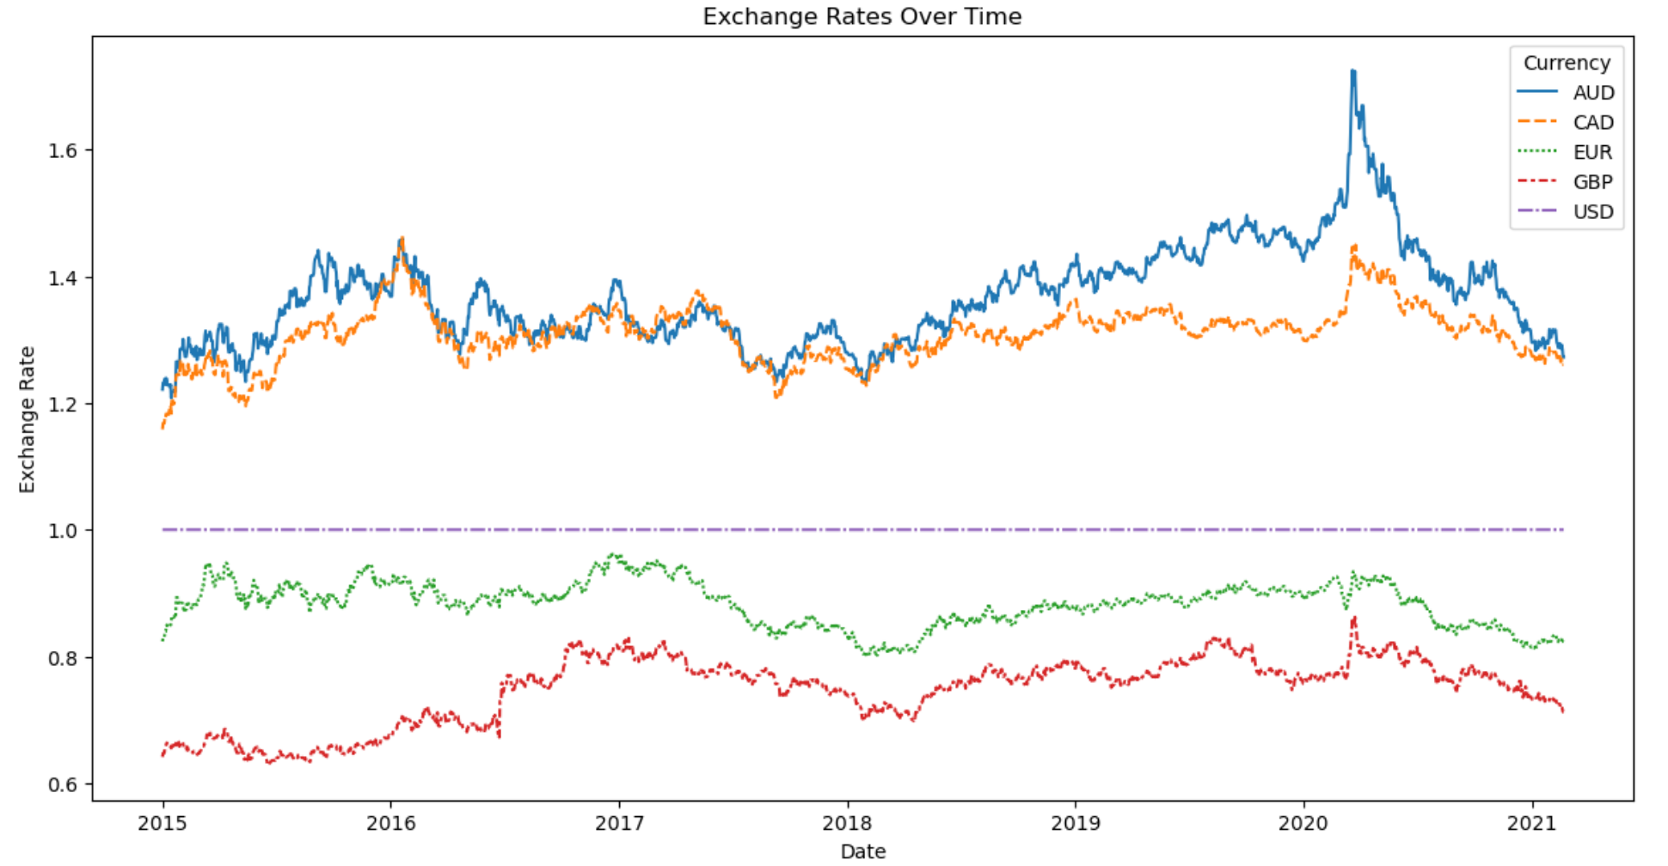

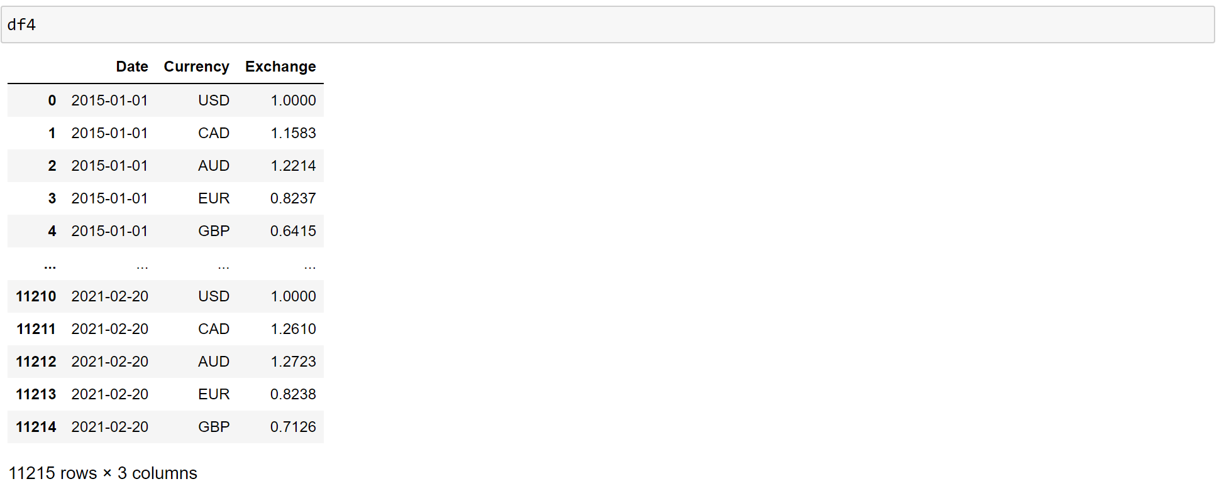

**MYSQL DATABASE**

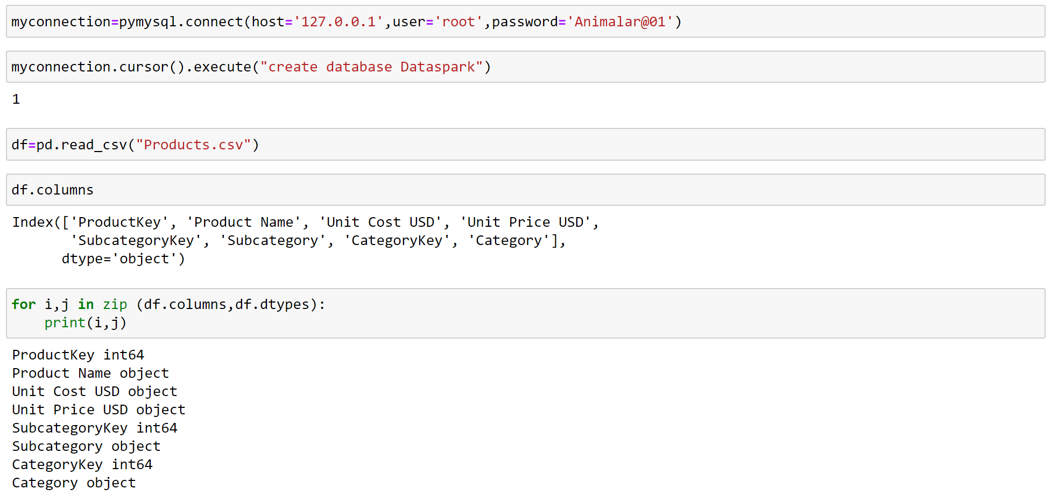

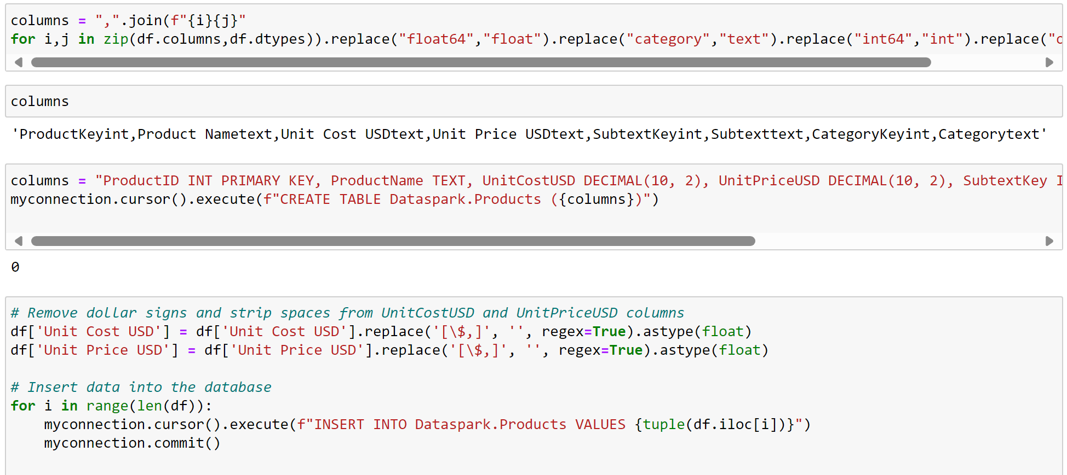

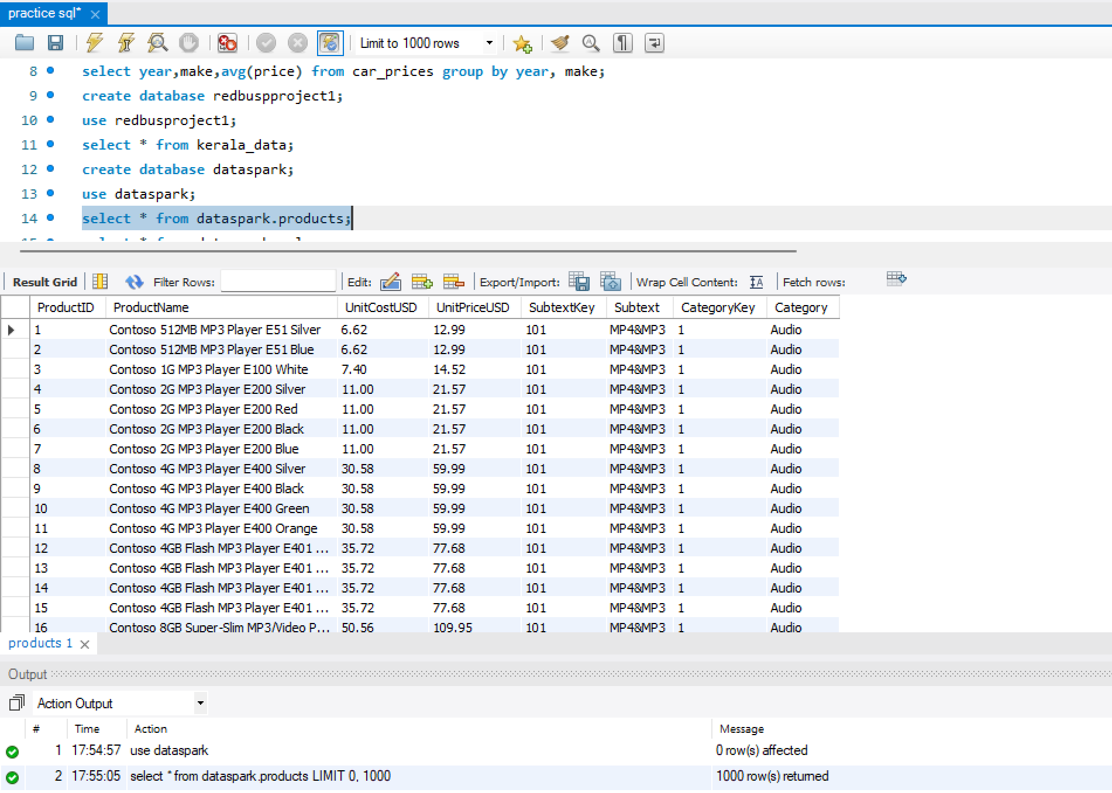

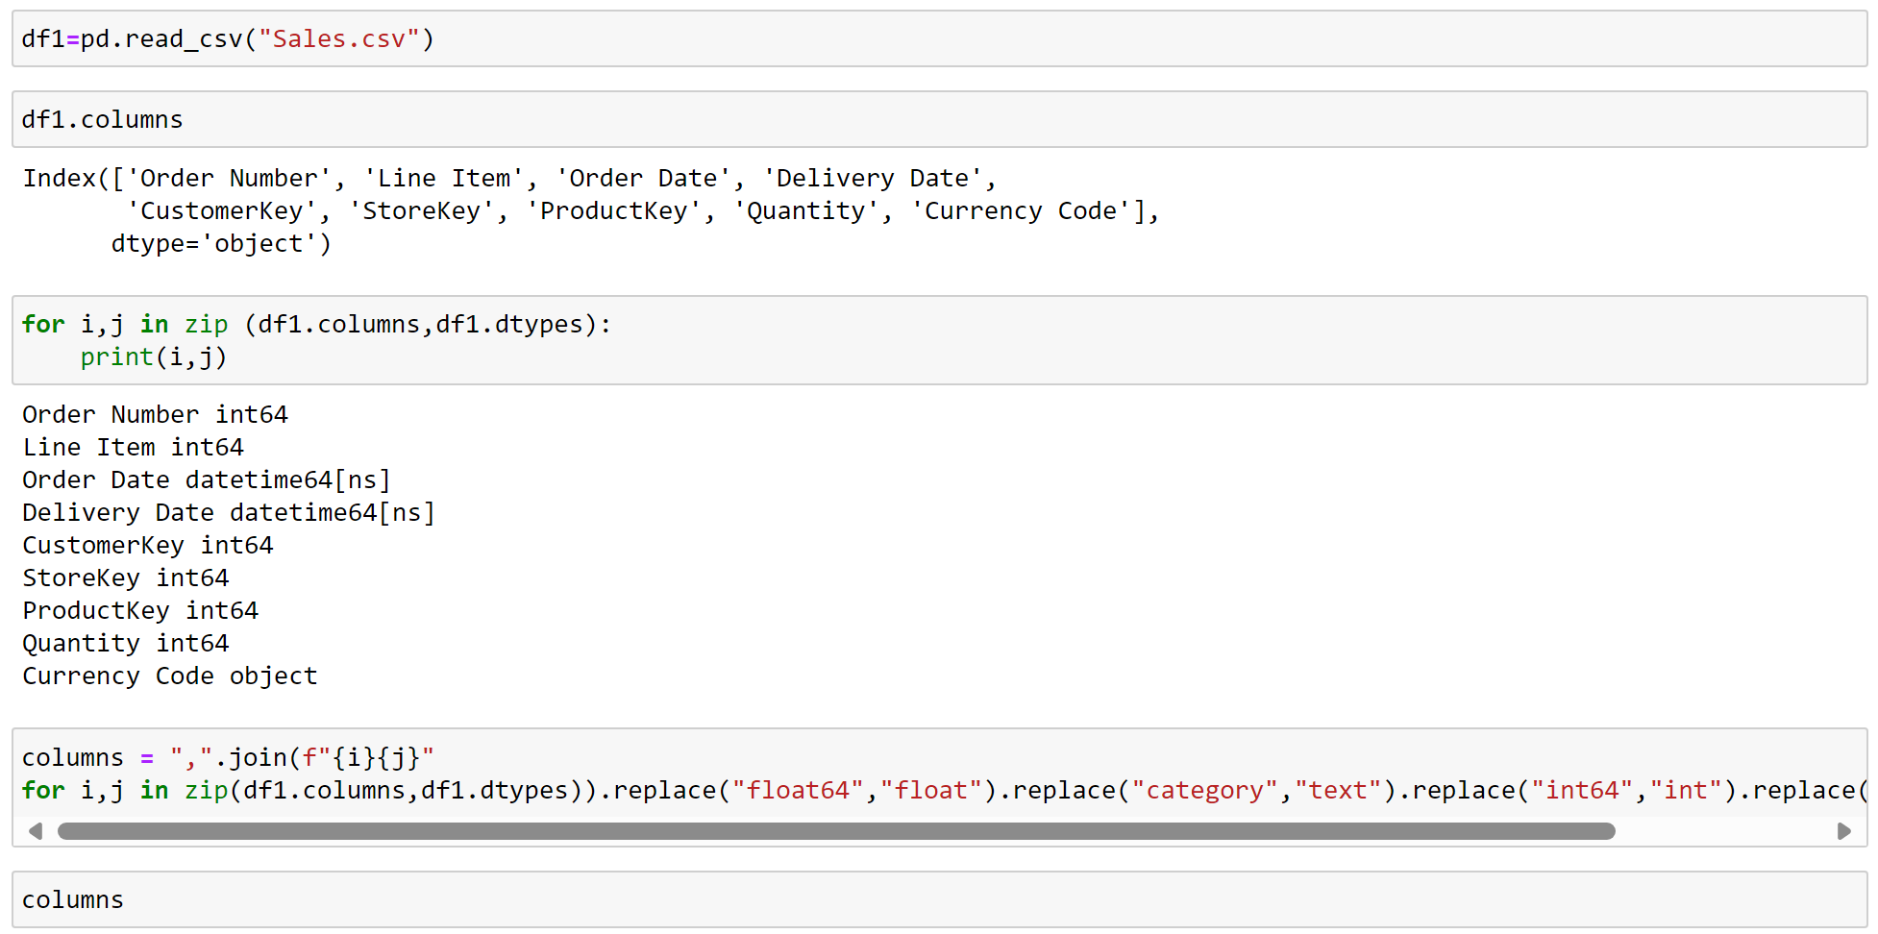

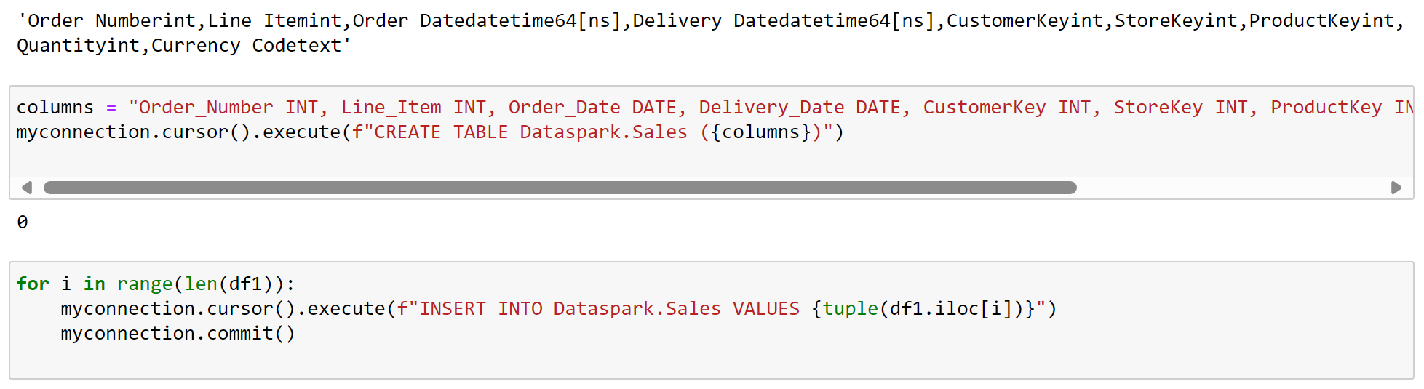

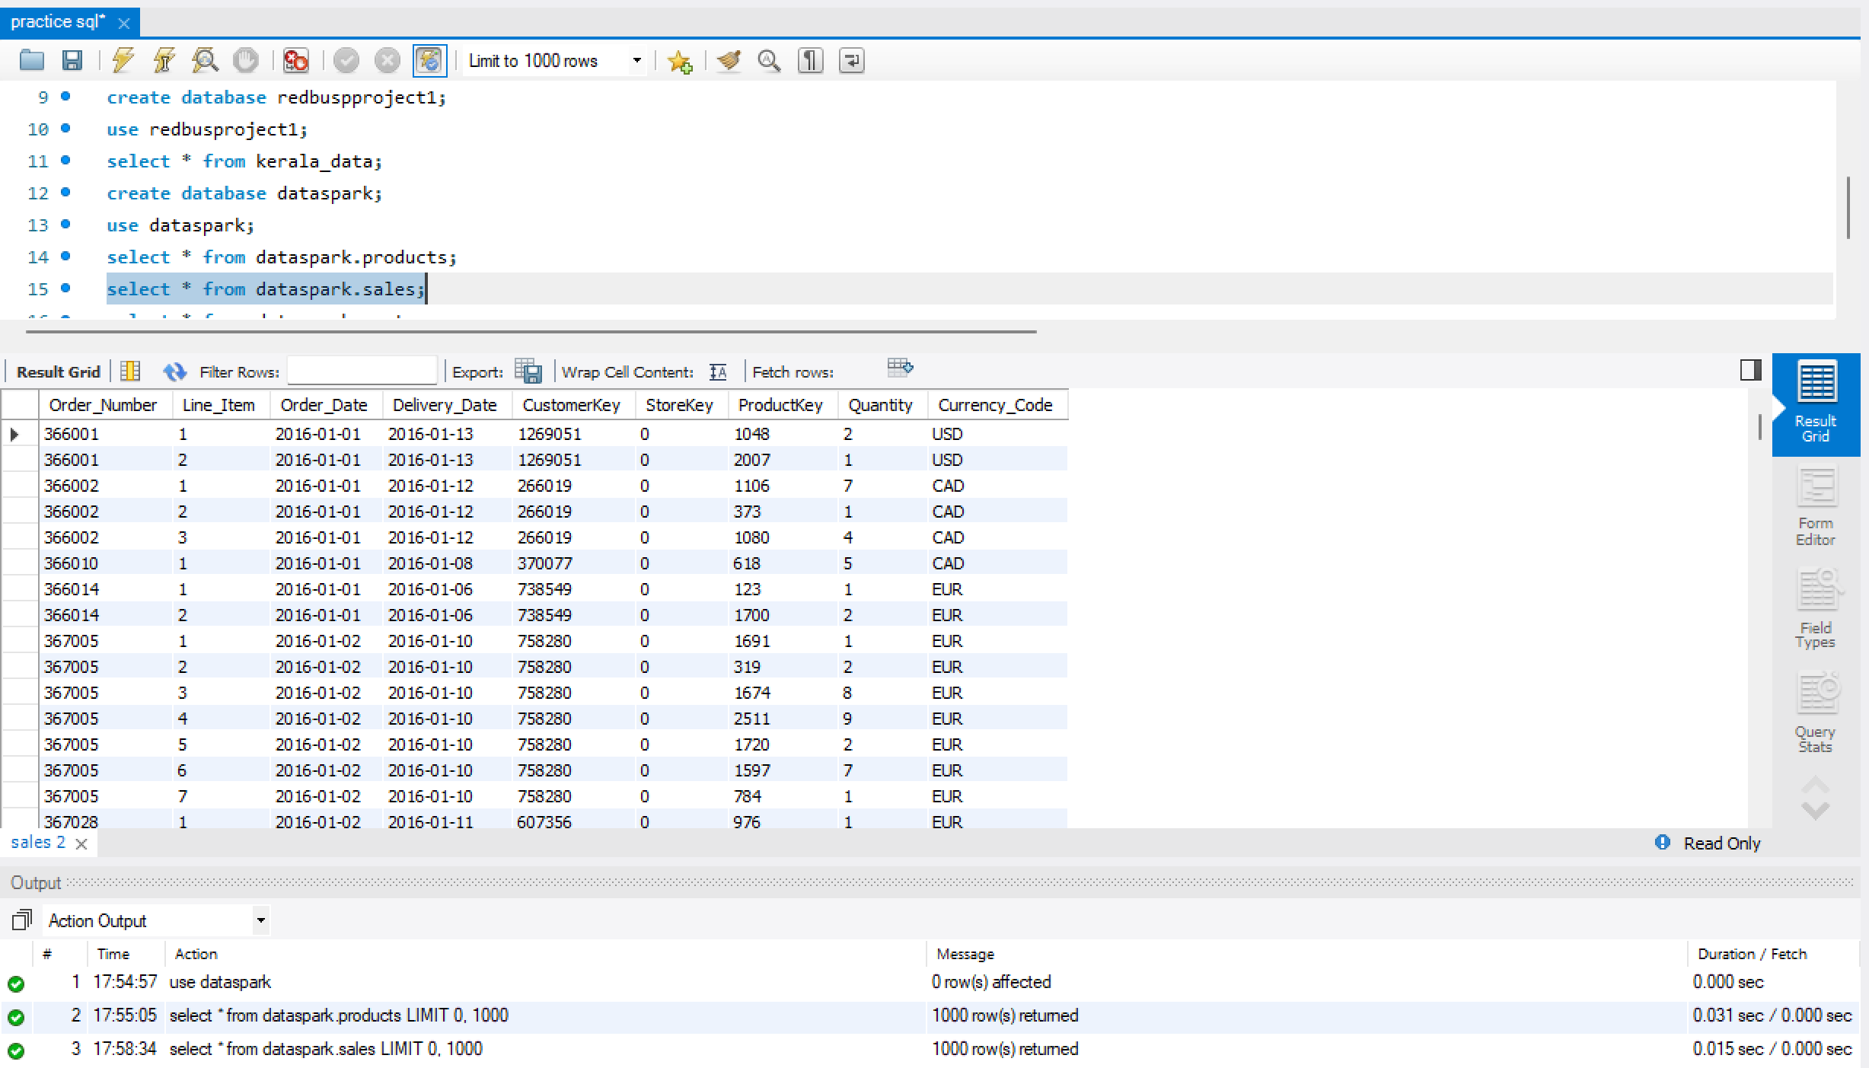

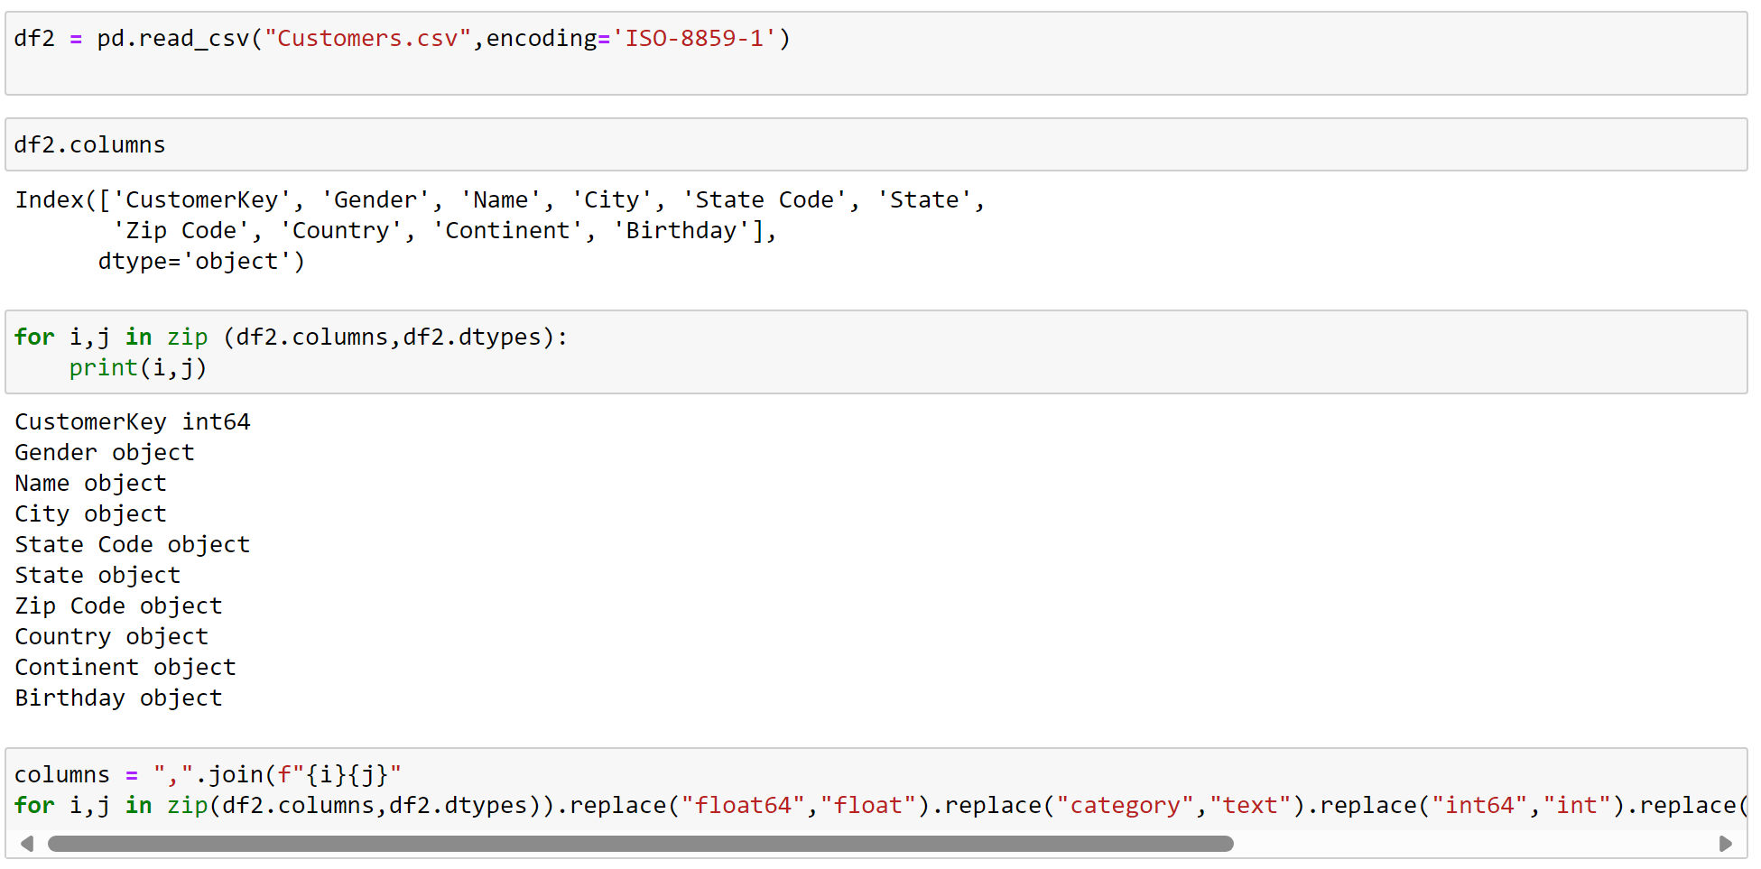

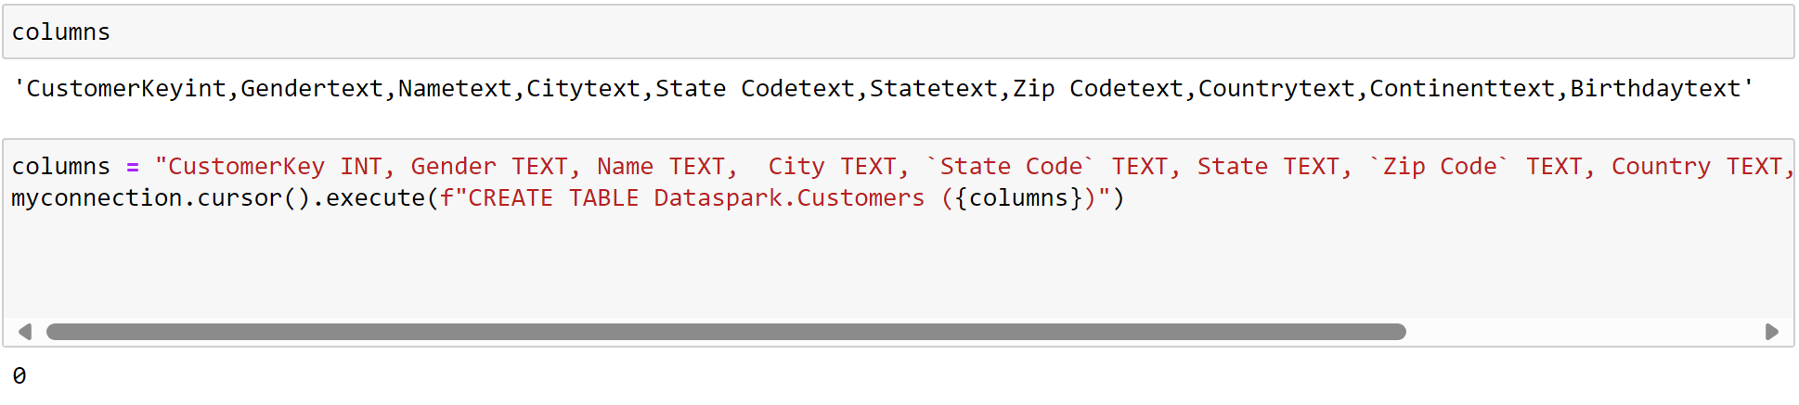



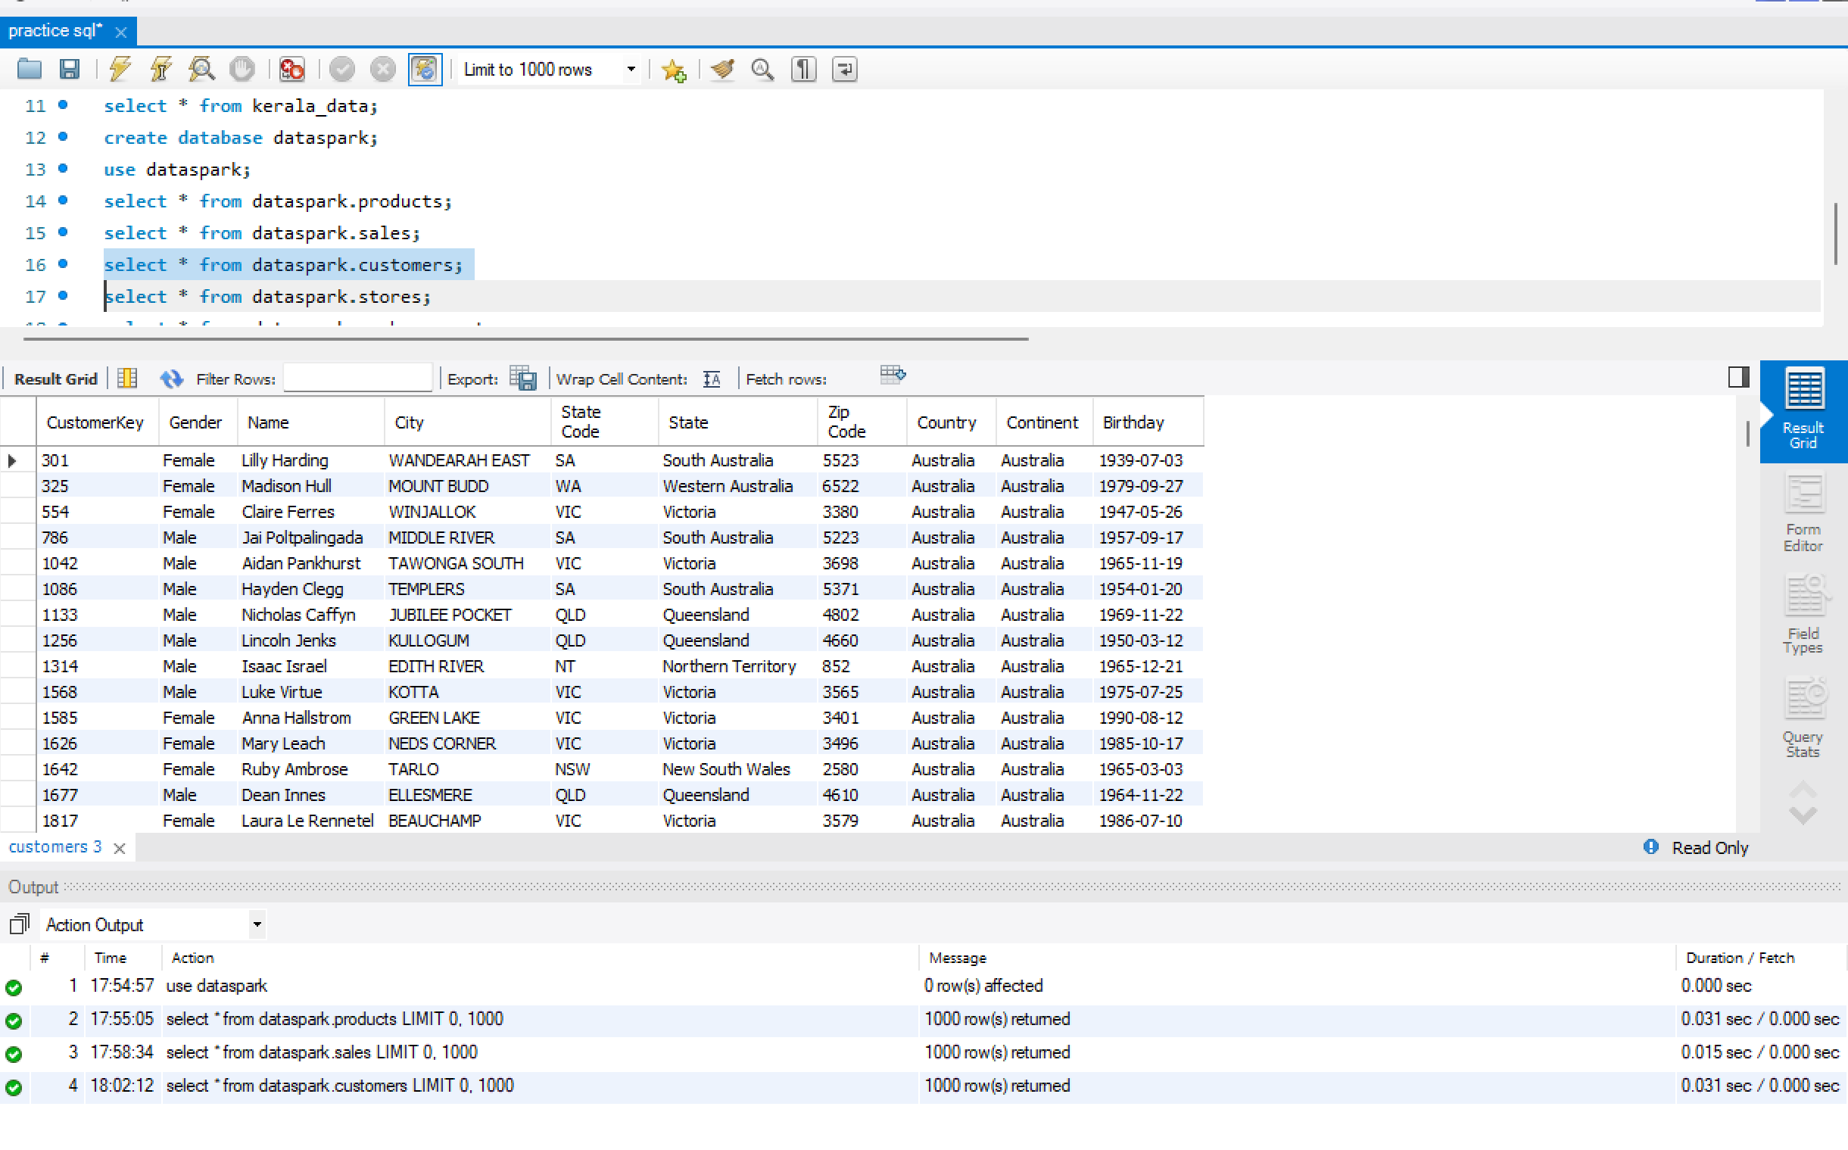

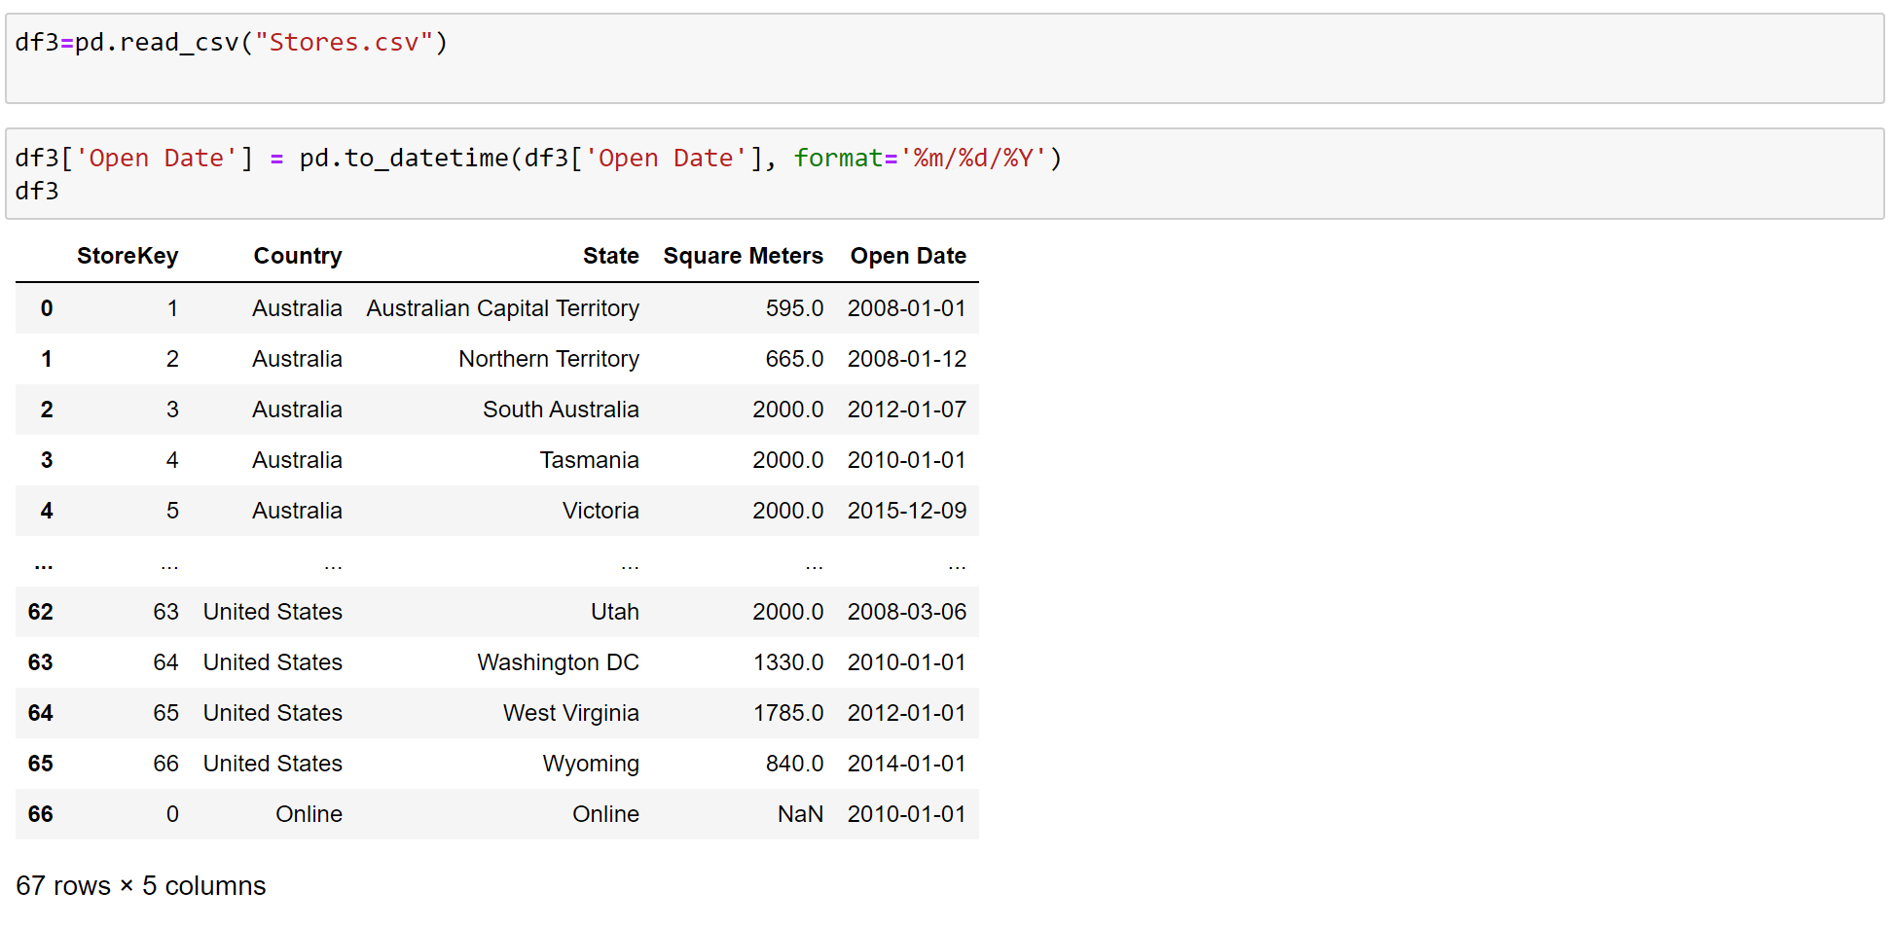

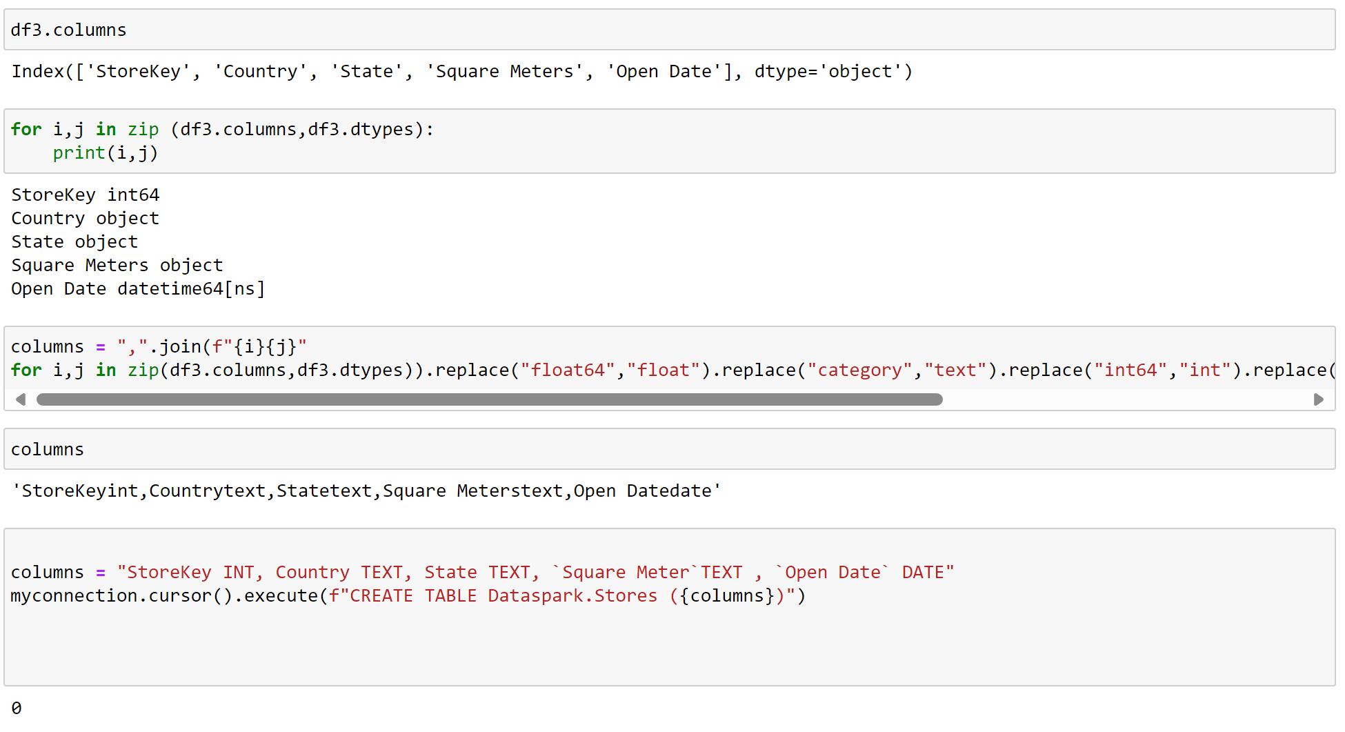



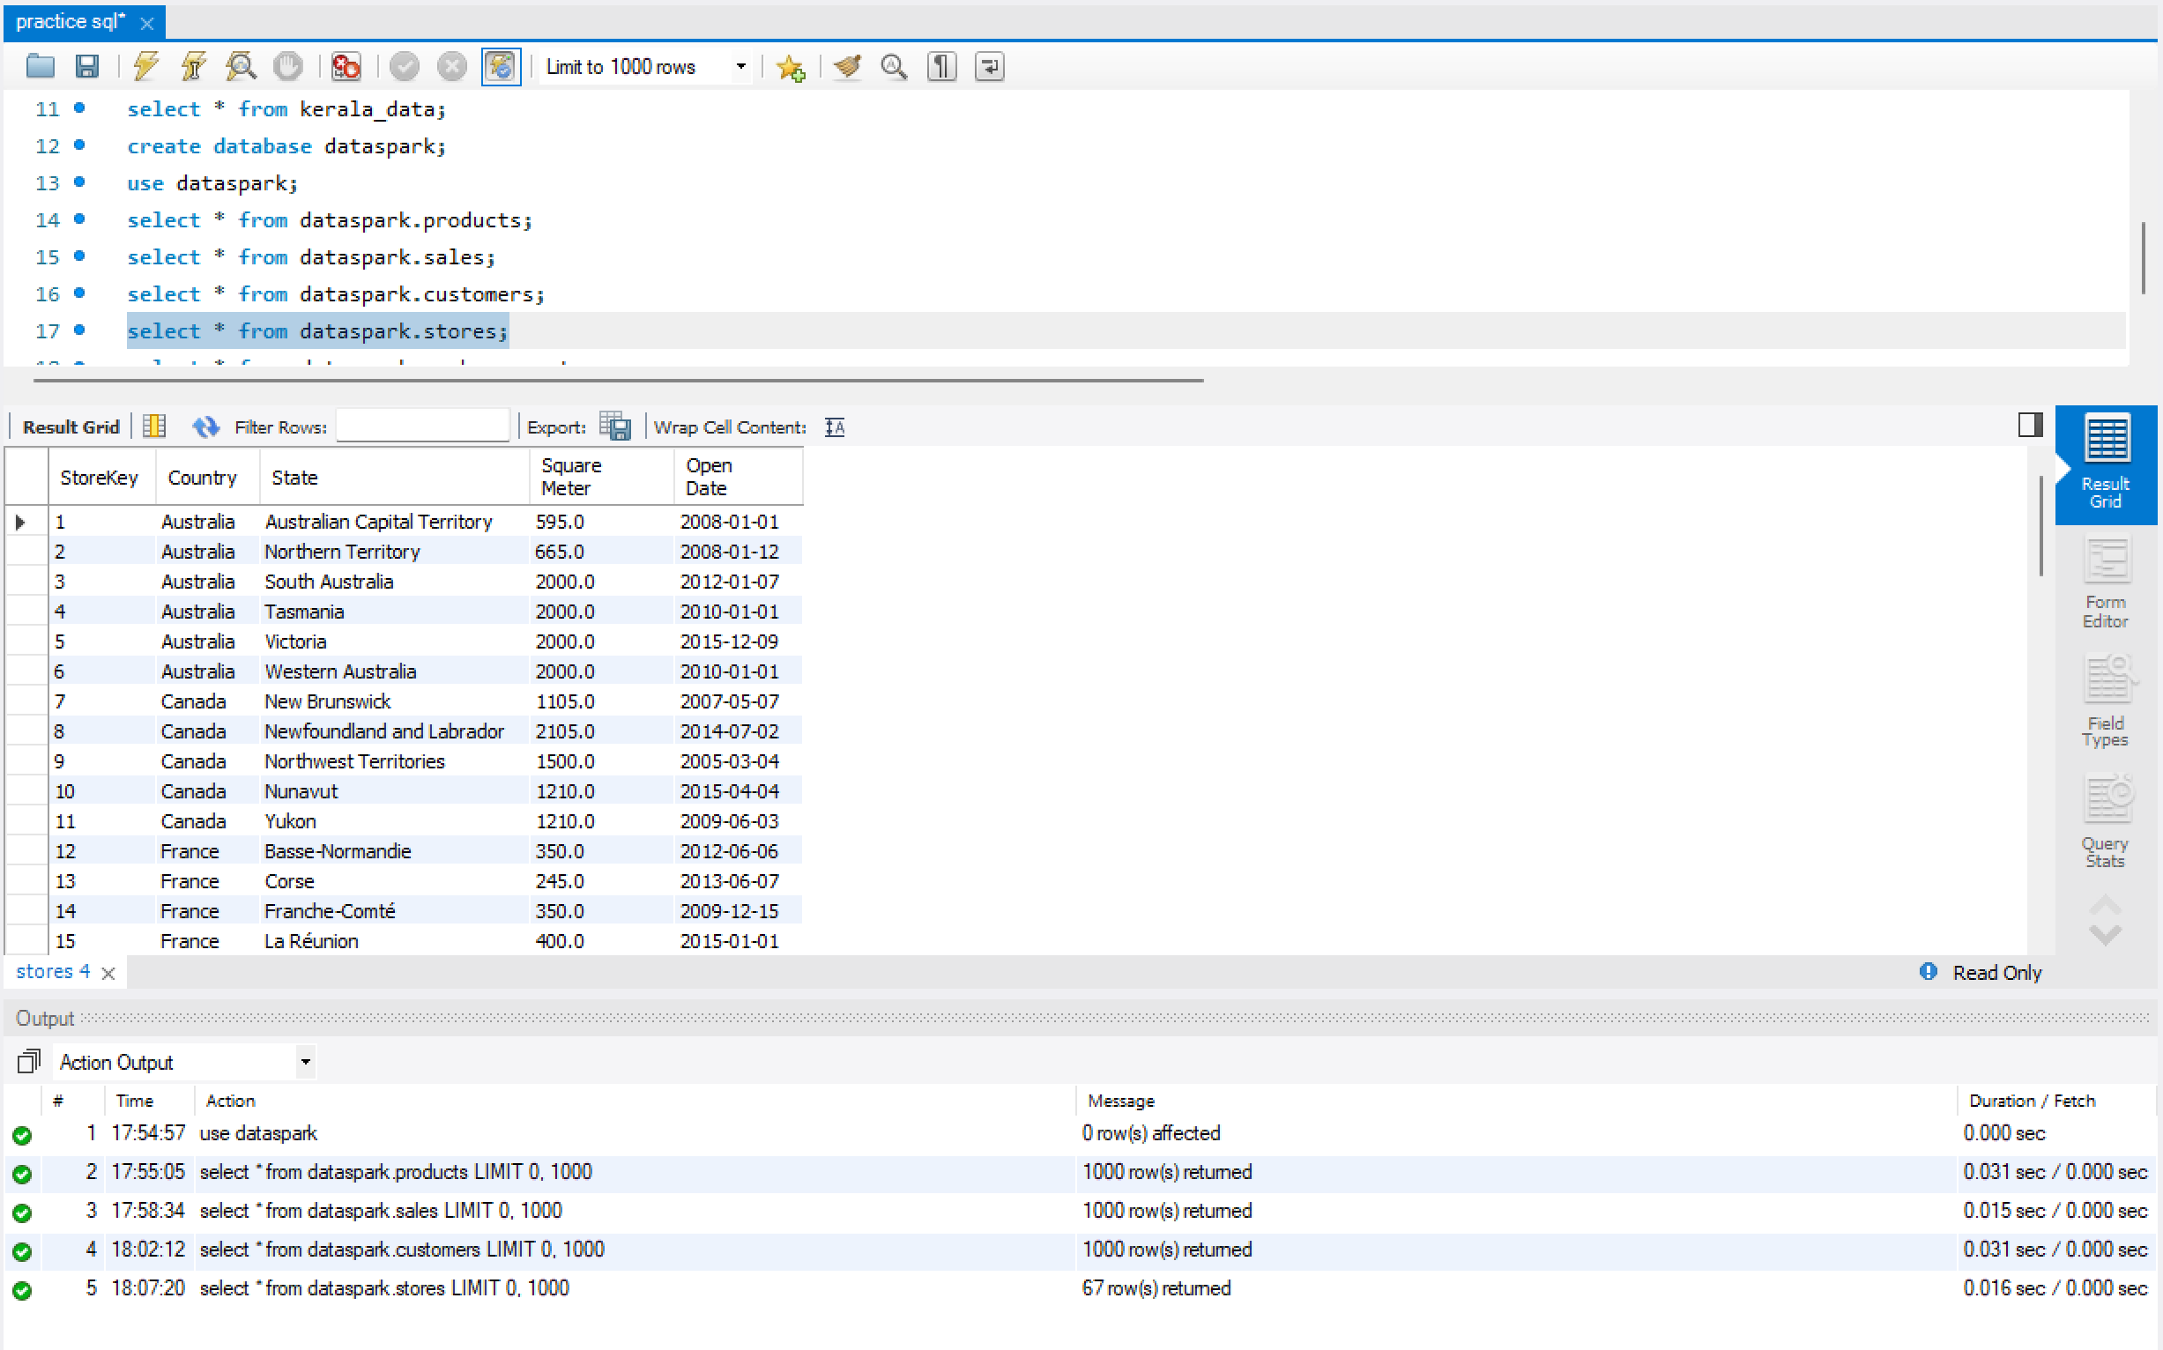

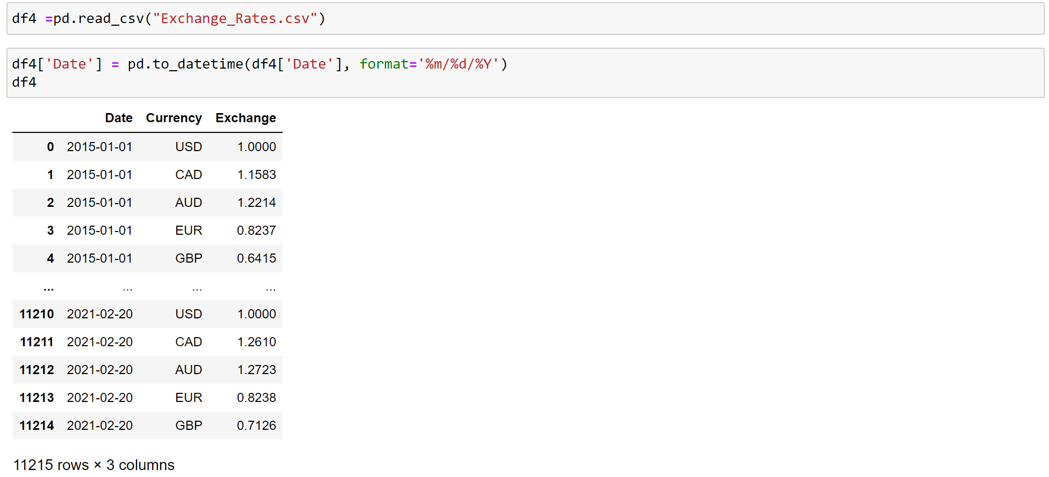

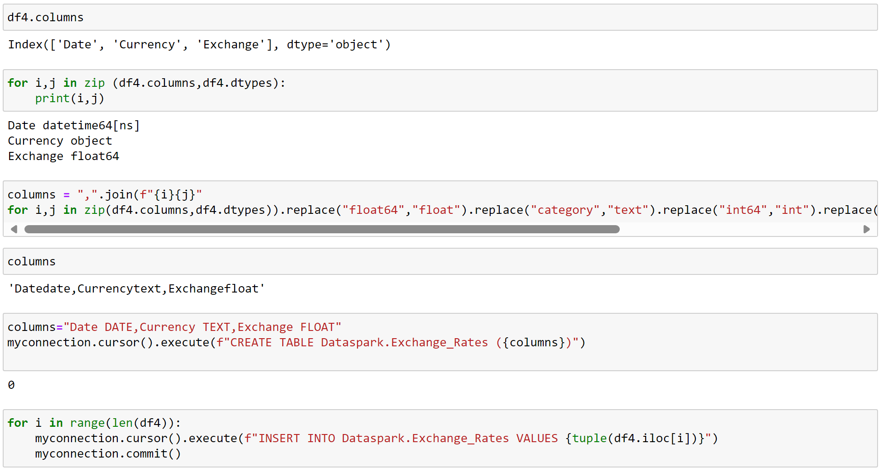

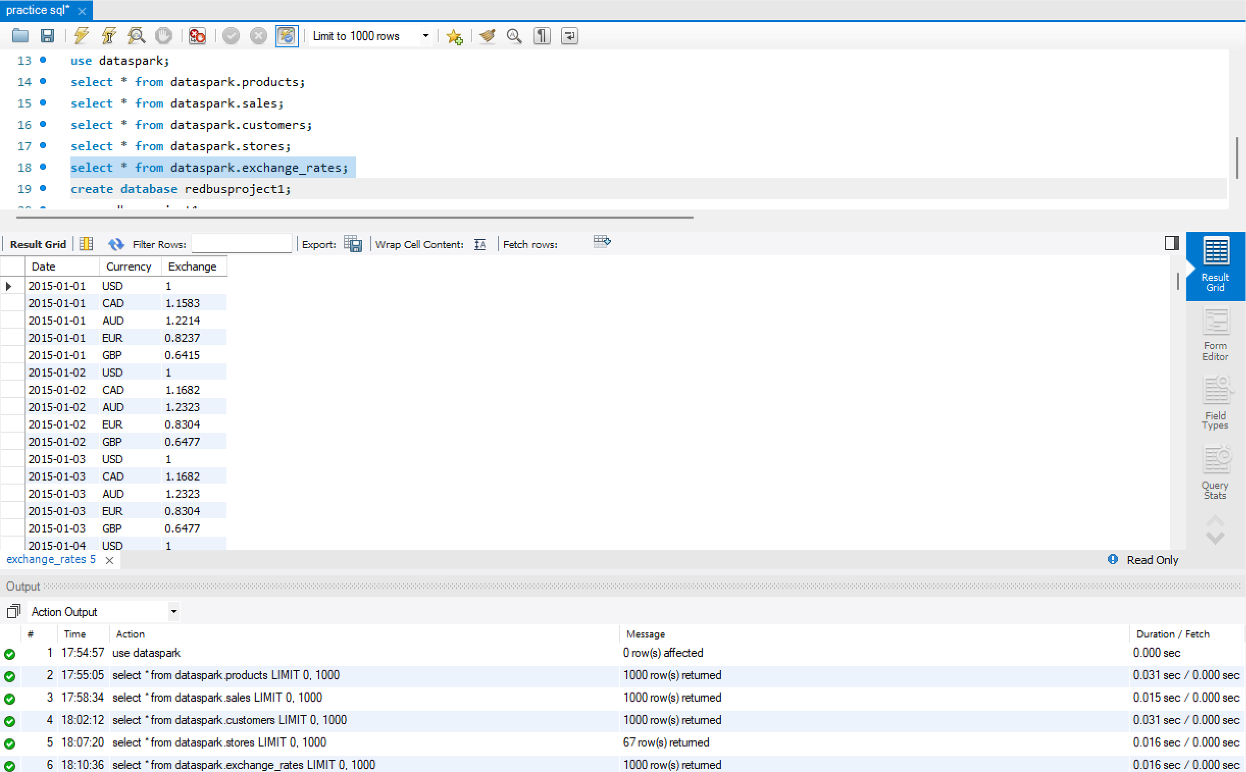

**Power BI Dashboard**

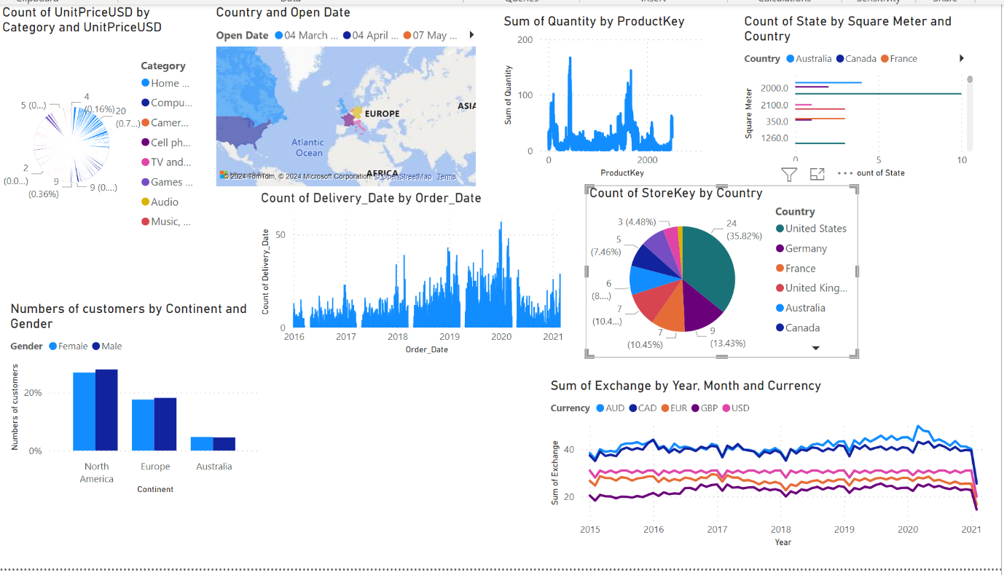

**Key Insights:**

1. **Top-Selling Products:** Identified the most popular electronics products across different regions.
2. **Sales Trends:** Noticed a significant increase in sales during the holiday season and a decline in off-peak periods.
3. **Customer Demographics:** Observed that a certain age group, gender, or region dominates the purchasing behavior for specific products.
4. **Inventory Optimization:** Discovered inefficiencies in inventory management, leading to out-of-stock or overstock issues.
5. **Regional Insights:** Found certain regions underperforming in sales, indicating potential marketing or supply chain challenges.

**7. Conclusion**

The DataSpark project successfully analyzed retail data from the electronics industry, providing critical insights into sales performance, customer behavior, and inventory management. By leveraging tools like Python, SQL, and Power BI the project demonstrated how data-driven strategies can help retailers improve decision-making and optimize operations.

**8. Future Work**

For future improvements:

* **Predictive Modeling:** Implement machine learning algorithms to predict future sales trends and customer behavior.
* **Real-Time Analytics:** Set up real-time data processing for dynamic inventory management.
* **Advanced Customer Analytics:** Dive deeper into customer segmentation using clustering algorithms to enhance marketing strategies.

**9. References**

* Python libraries: Pandas, NumPy, Matplotlib, Seaborn
* SQL documentation: MySQL
* Power BI

Top of Form

Bottom of Form